1.Five Different exception in Spring?

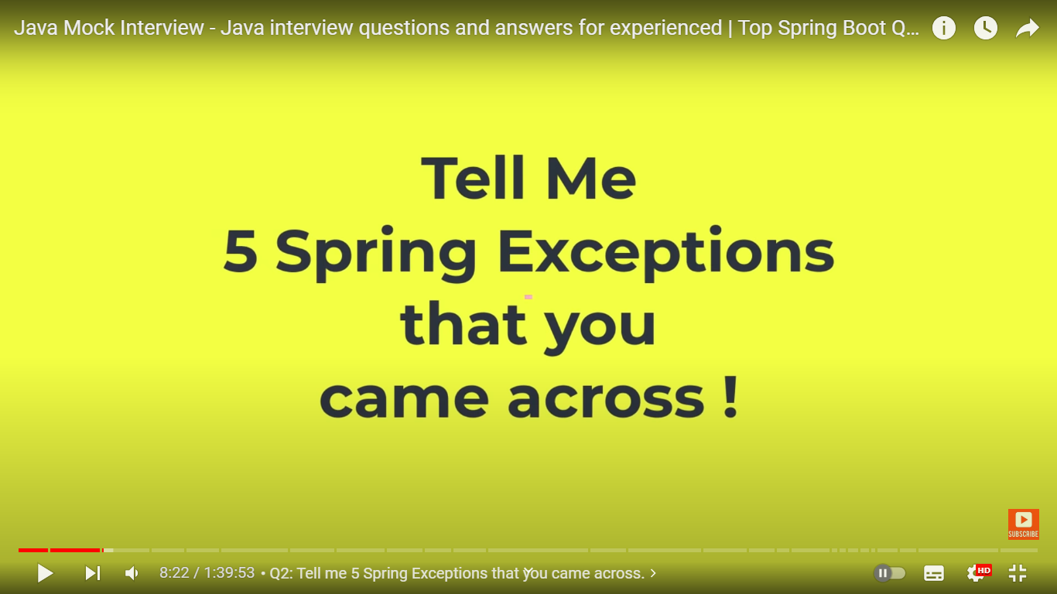

NoUniqueBeanDefinationException : two beans of same type.

Use @Qualifier or @Primary on one of the bean

BeanCreationException: Circular dependency

Emp class has Dept dependency and Dept class has Emp dependency.

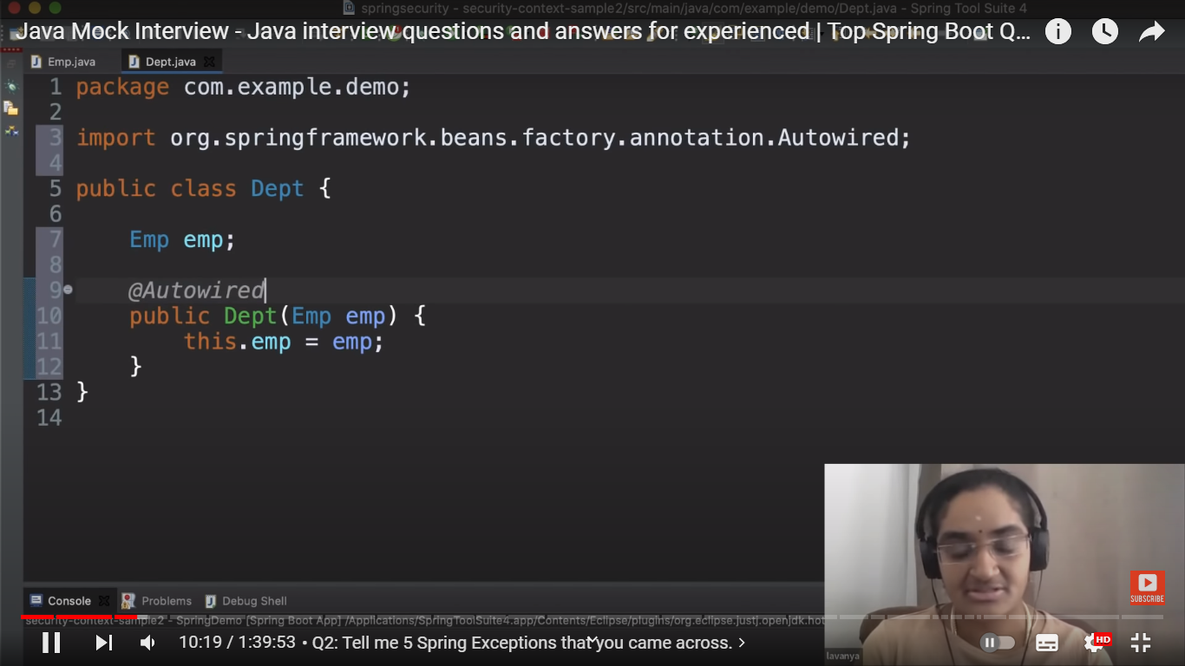

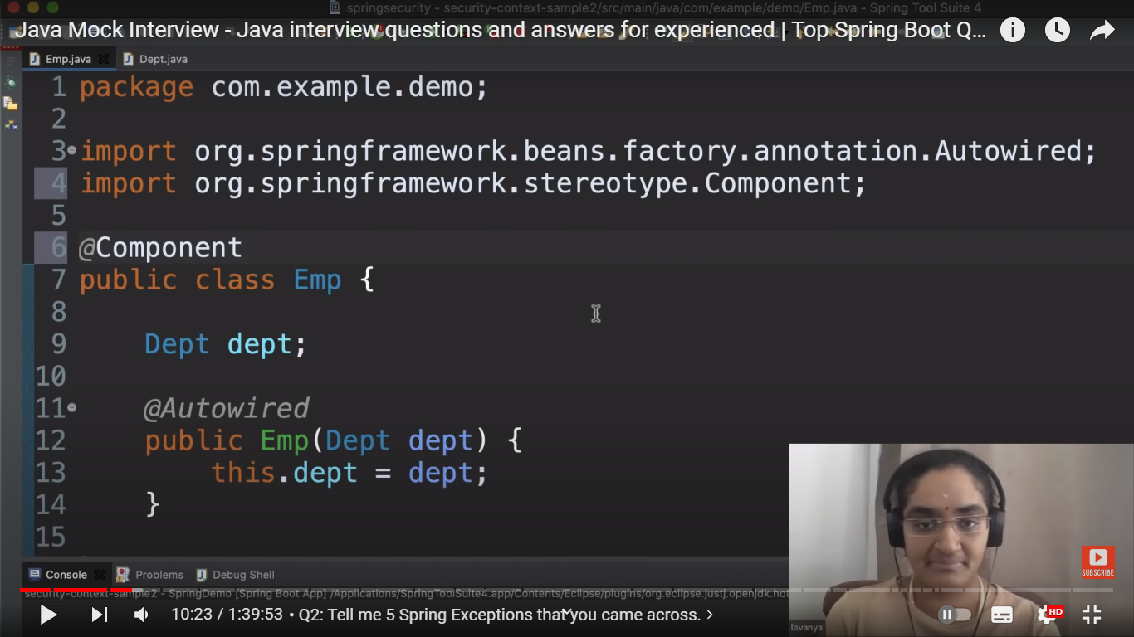

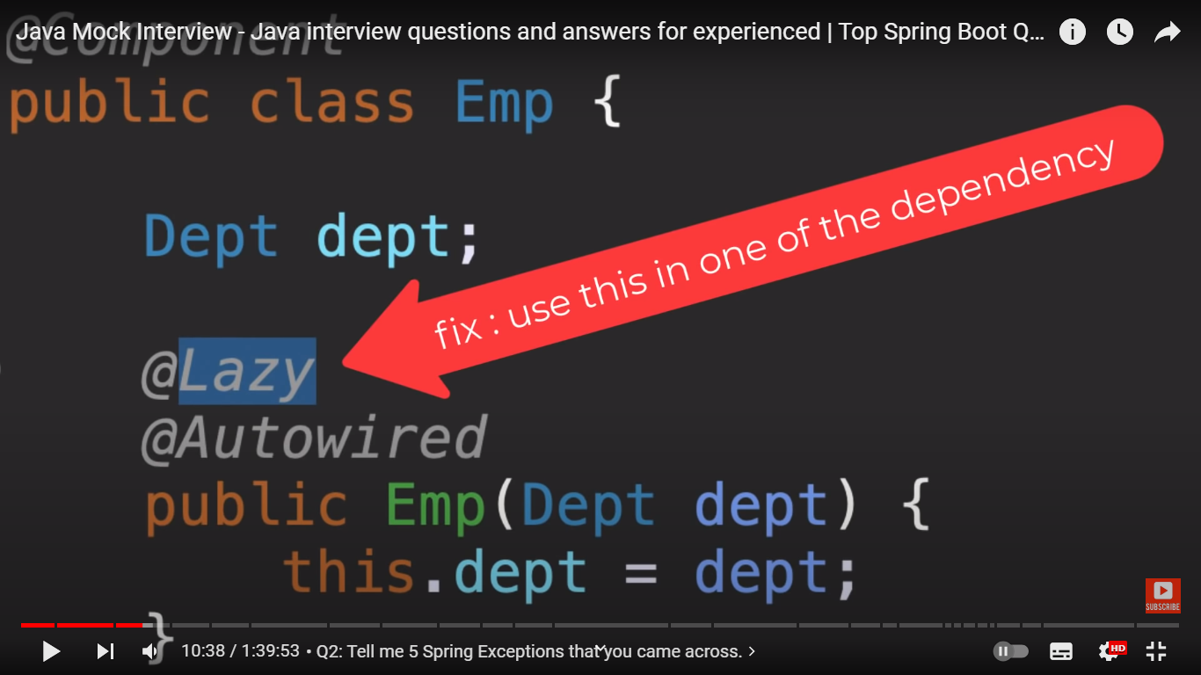

BeanInstantiationException:

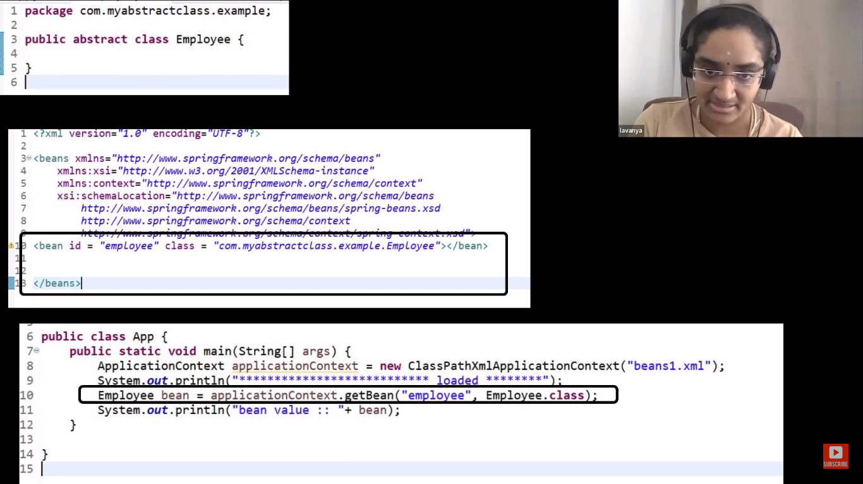

ApplicationContextException

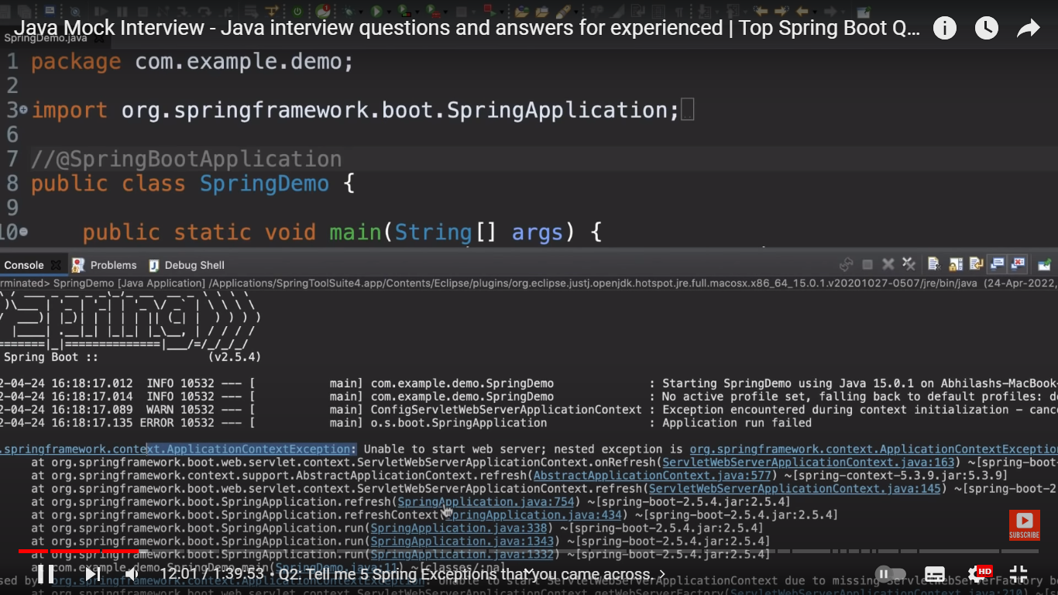

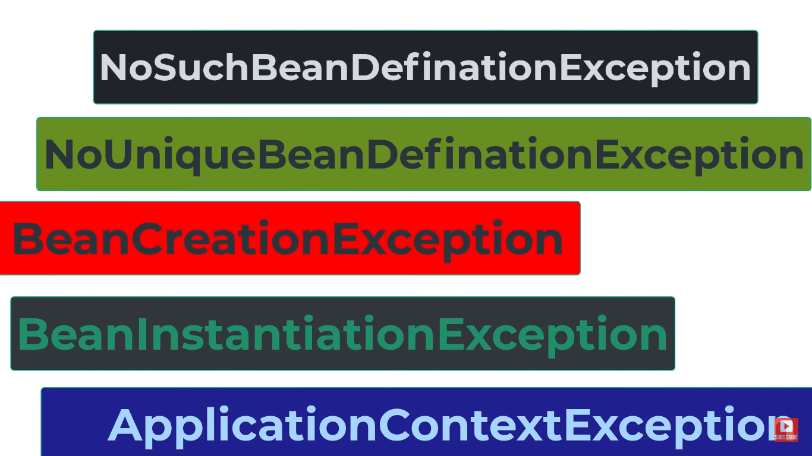

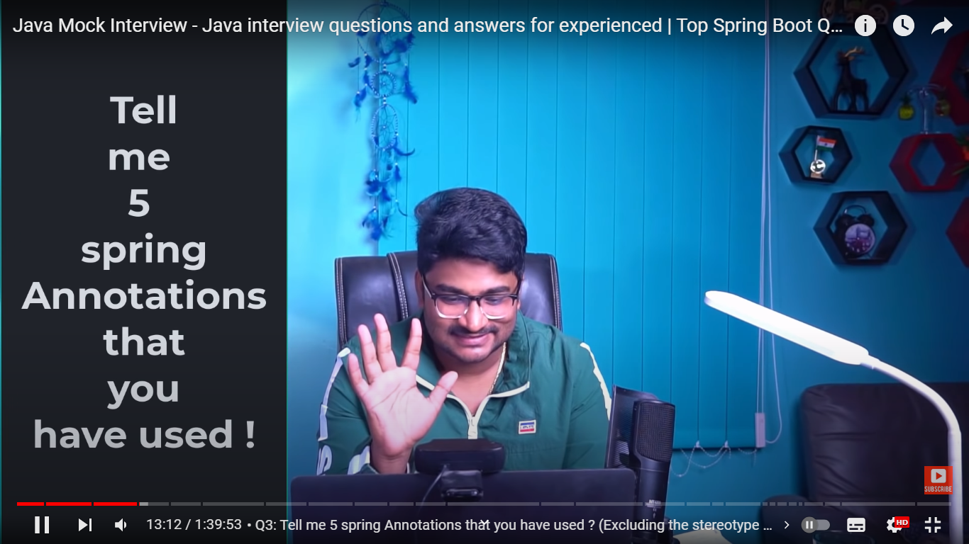

2. Do we need to add @Repository annotation on Spring Data JPA repository?

NO

3. What is BASE Repository , CRUD Repository , JPA Repository , PagingAndSortingRepository ?

<https://www.baeldung.com/spring-data-repositories#:~:text=Each%20of%20these%20defines%20its,deleting%20records%20in%20a%20batch>

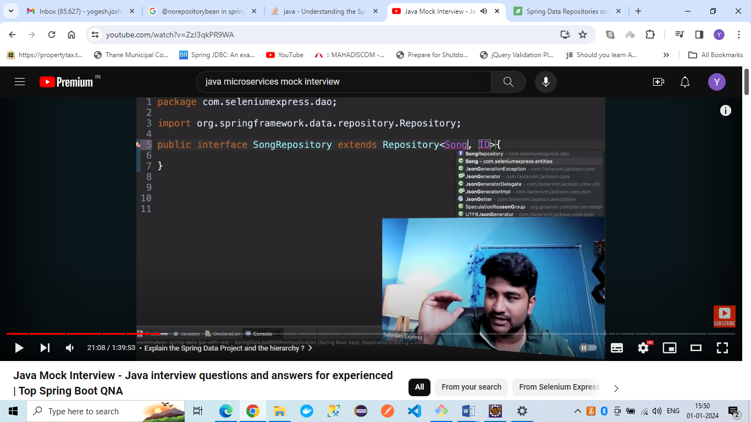

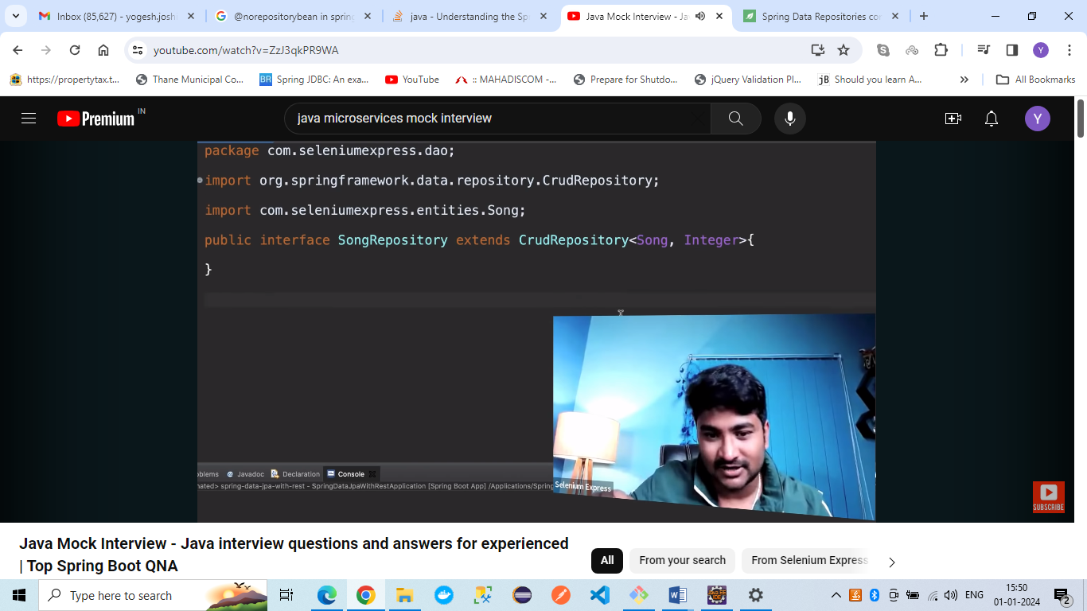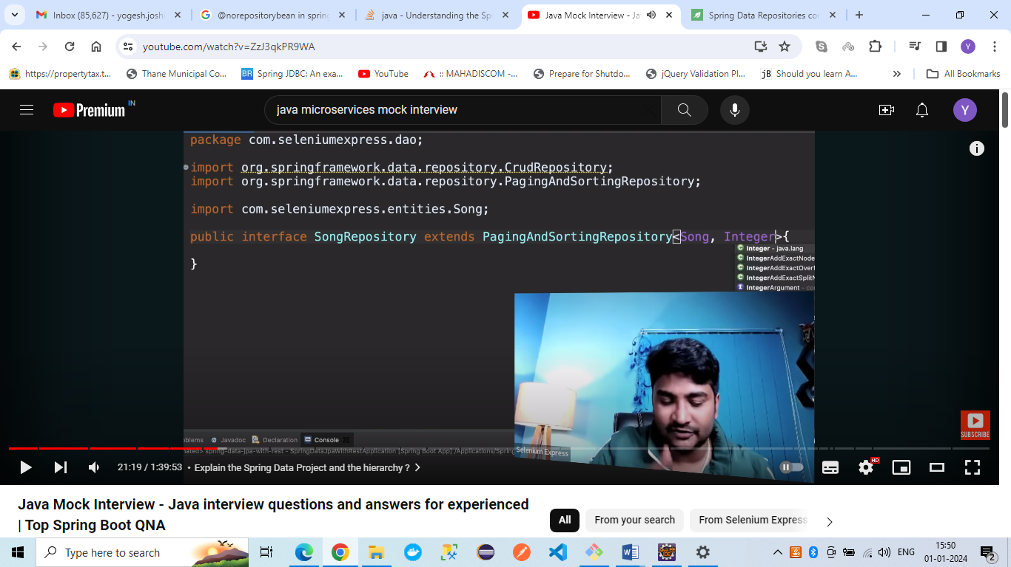

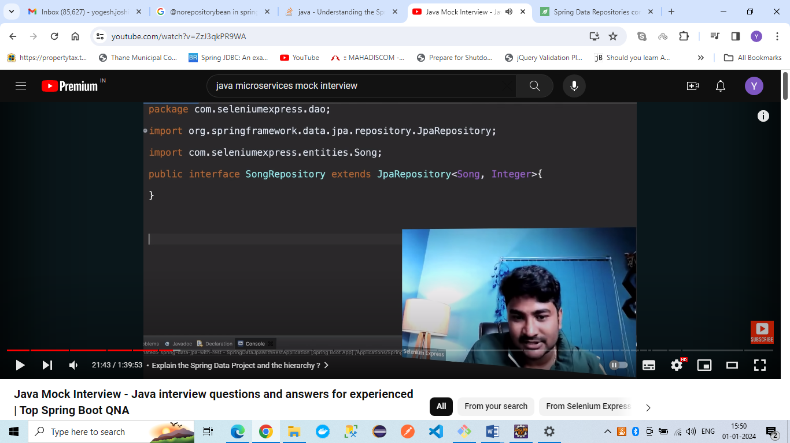

What is Spring Data JPA module ?

Spring Data JPA aims to improve the implementation of data access layers by reducing the amount of boilerplate code required .

Spring Data JPA offers the concept of Repository out of the box, which is a high-level abstraction for database access. Repository is an interface that contains method signatures for standard CRUD operations. Additional queries can also be declared on it .

Transaction management is also taken care by Spring Data JPA.

Spring Data JPA will create Data Source with the properties provided in application.yaml.

It provides 3 interfaces Repository , CRUDRepository, PagingAndSortingRepo

By default Hibernate is used as ORM. So it has JPArepository.

SpringData provides easy methods like FindAll,FindByID,DeleteById methods

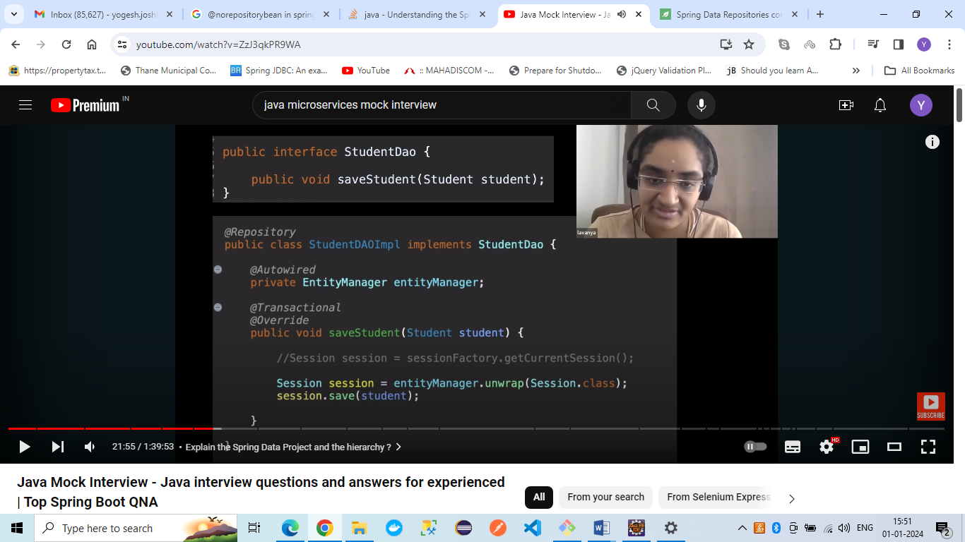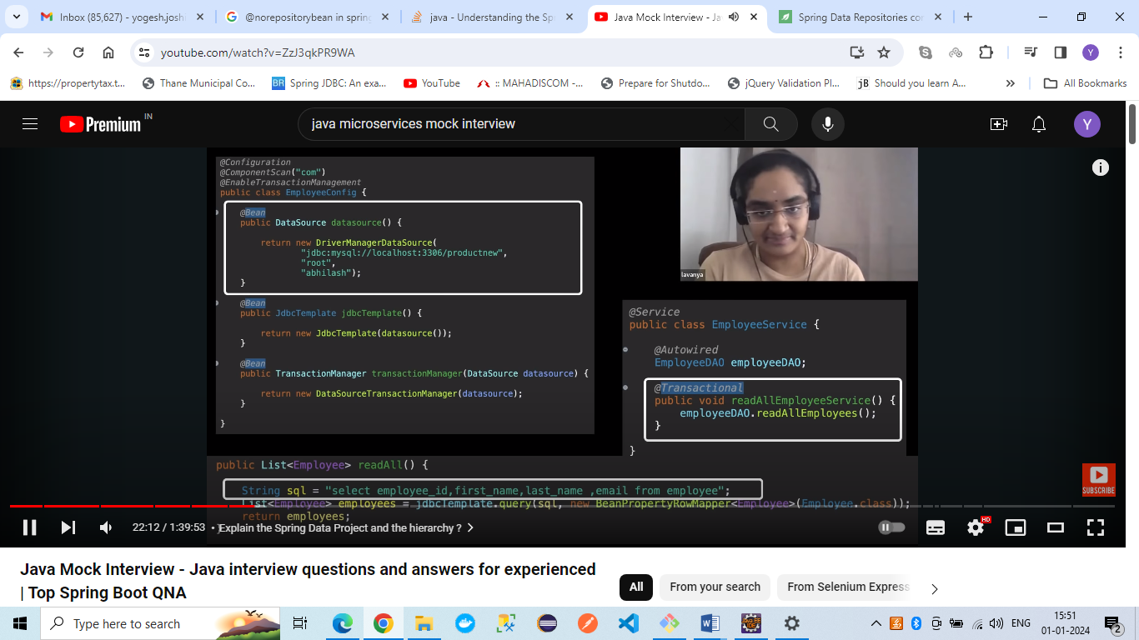

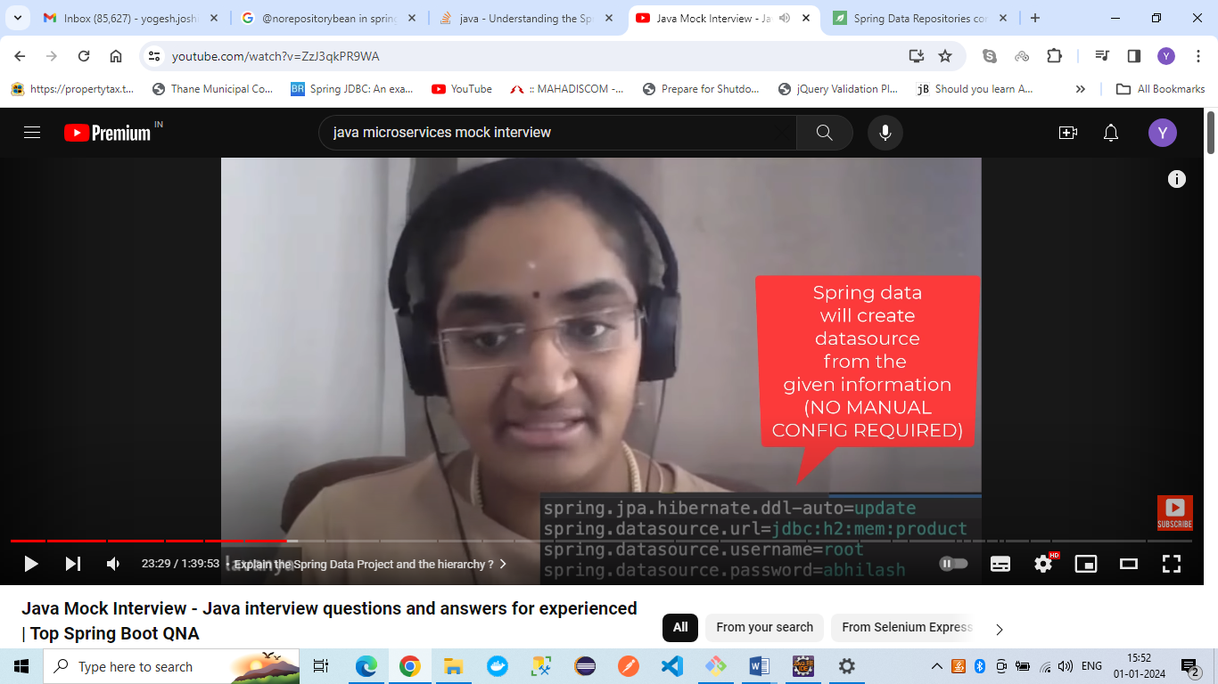

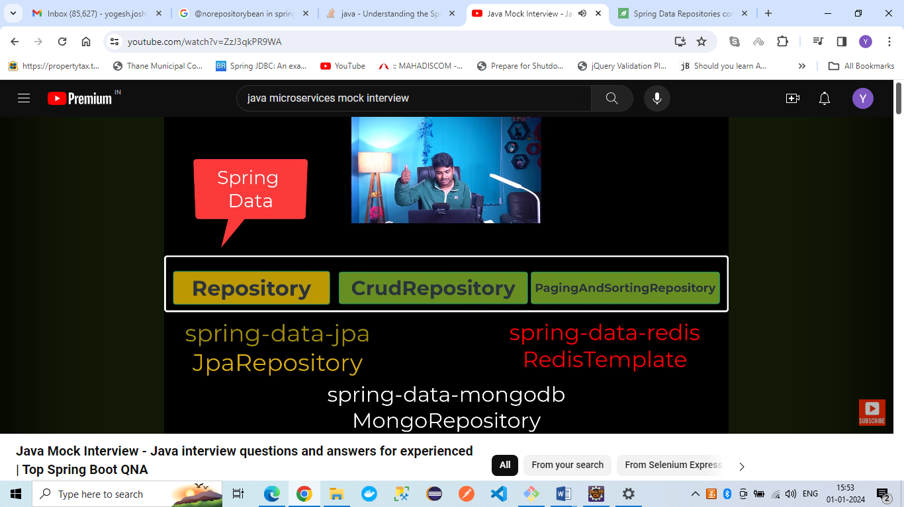

4. What is @NoRepositoryBean annotation:

If we don’t want Spring to initialize the interface then add this annotation

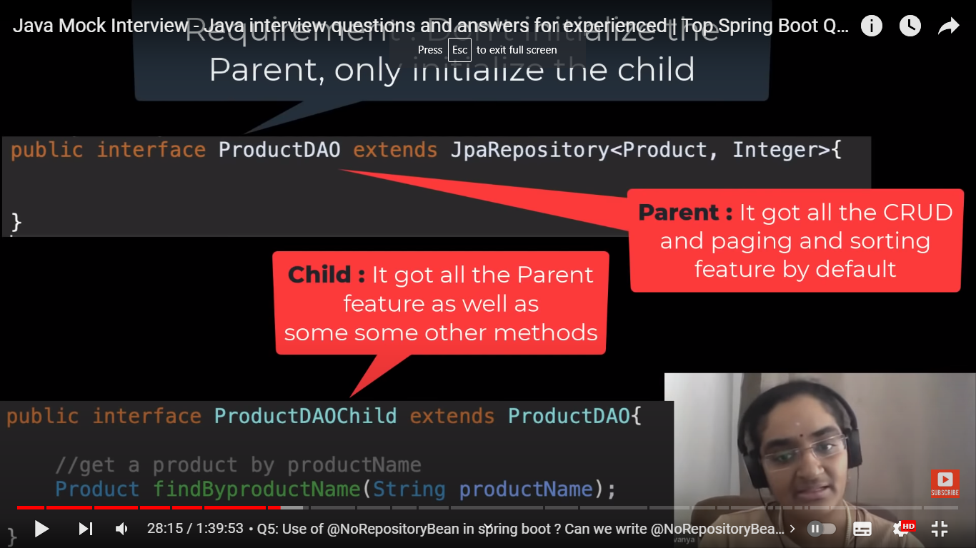

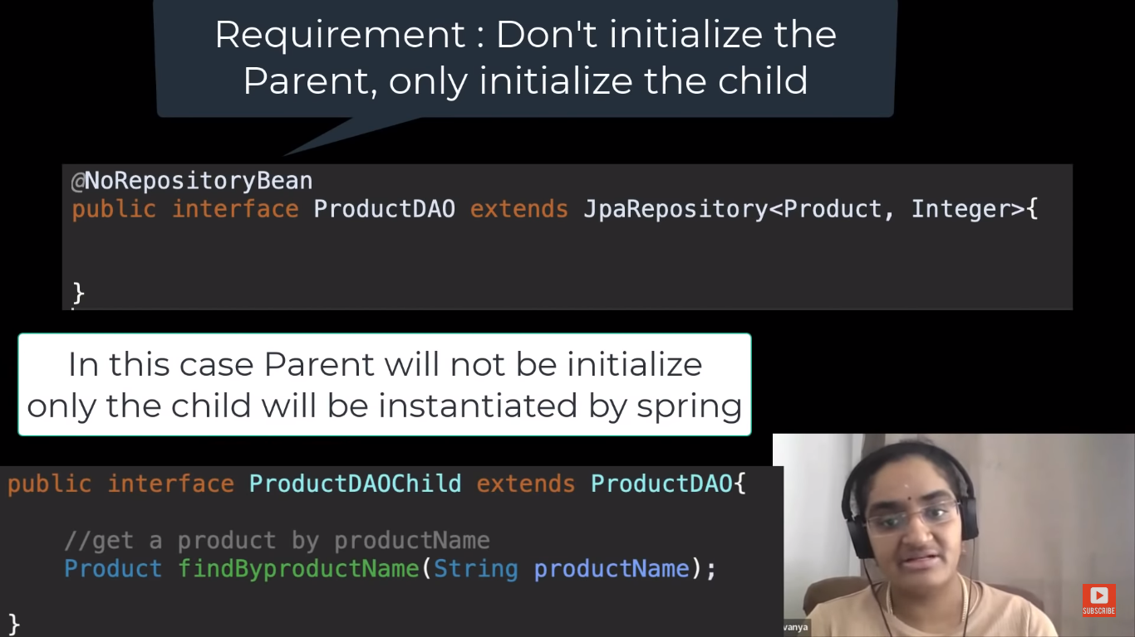

5> What is a java config file and What is it' s limitations?

Class with @Configuration and has methods with @Bean

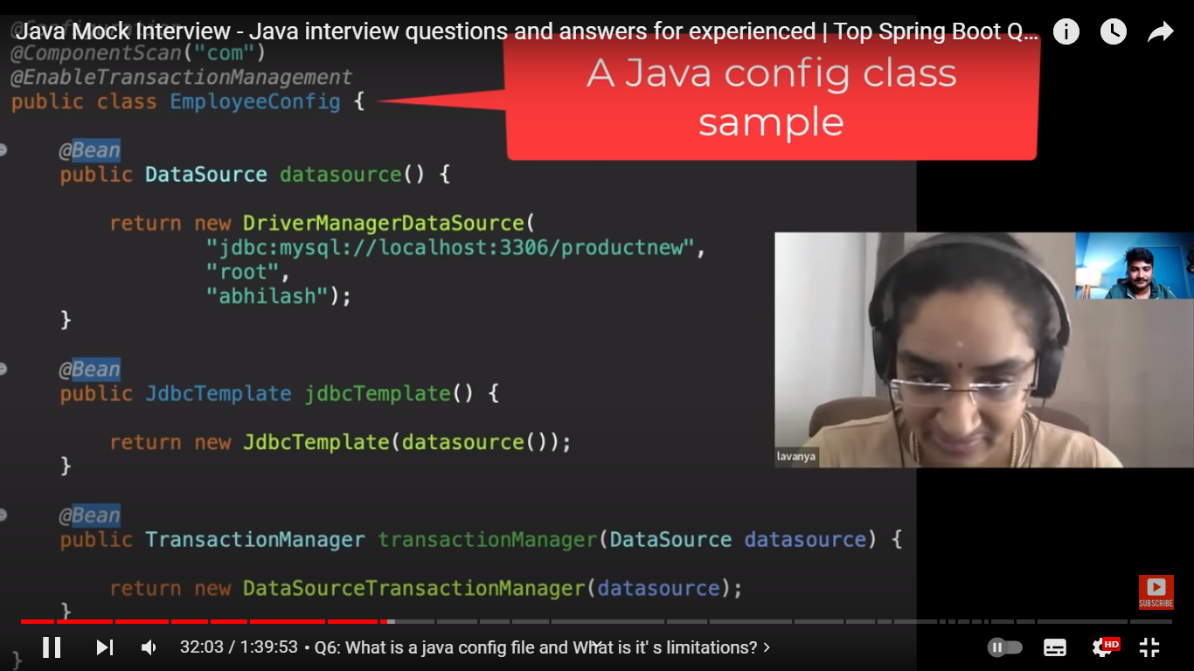

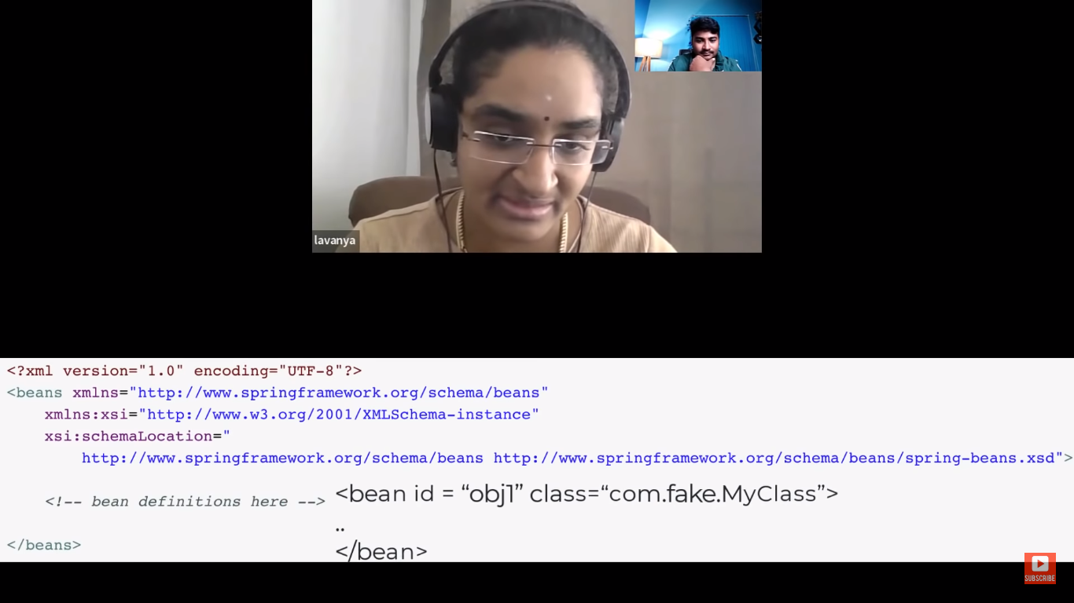

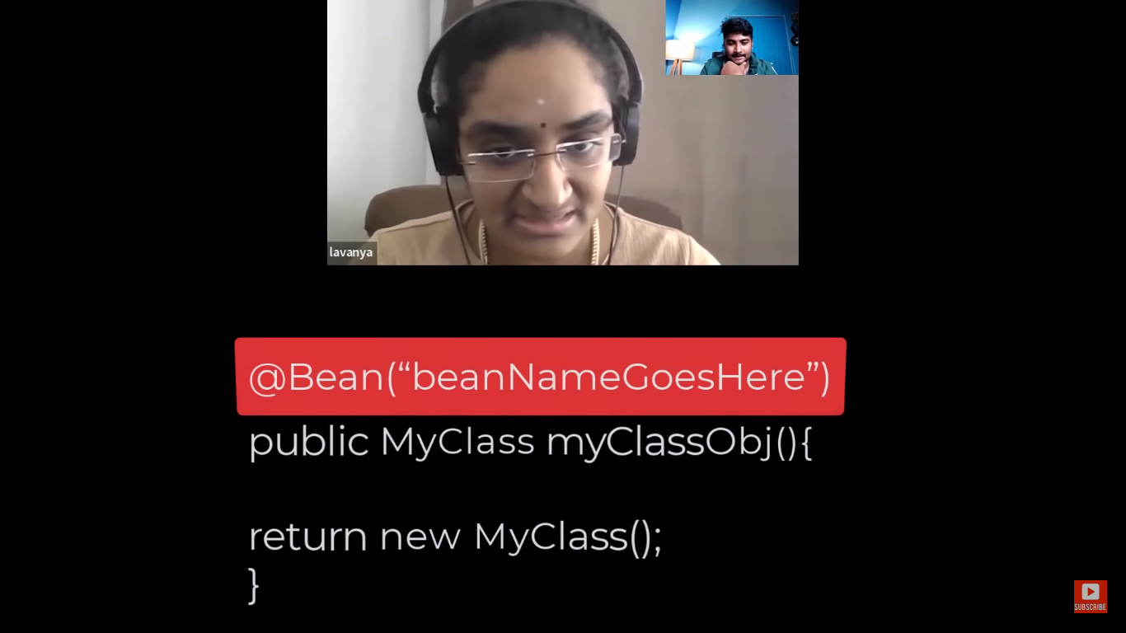

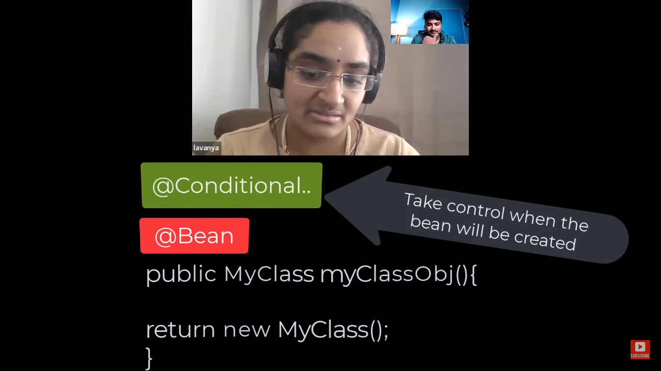

We can get hold of the class when to create Object by adding different Conditional Annotation.

We can also inject XML Config in Java Config using @ImportResource

Better Readability

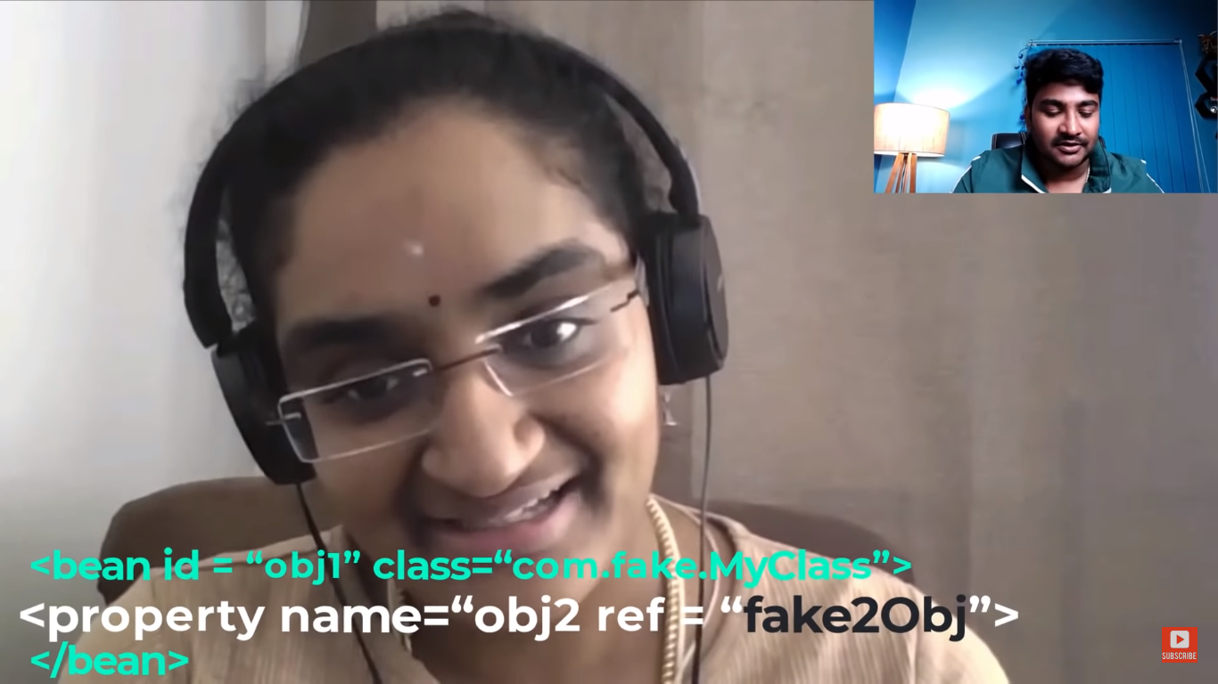

The above syntax for Bean Creation in XML will not give error at compile time if fake2Obj in ref tag is not present.

But when we are creating Spring Beans using @Bean annotation then we have compile time checks not run time checks.

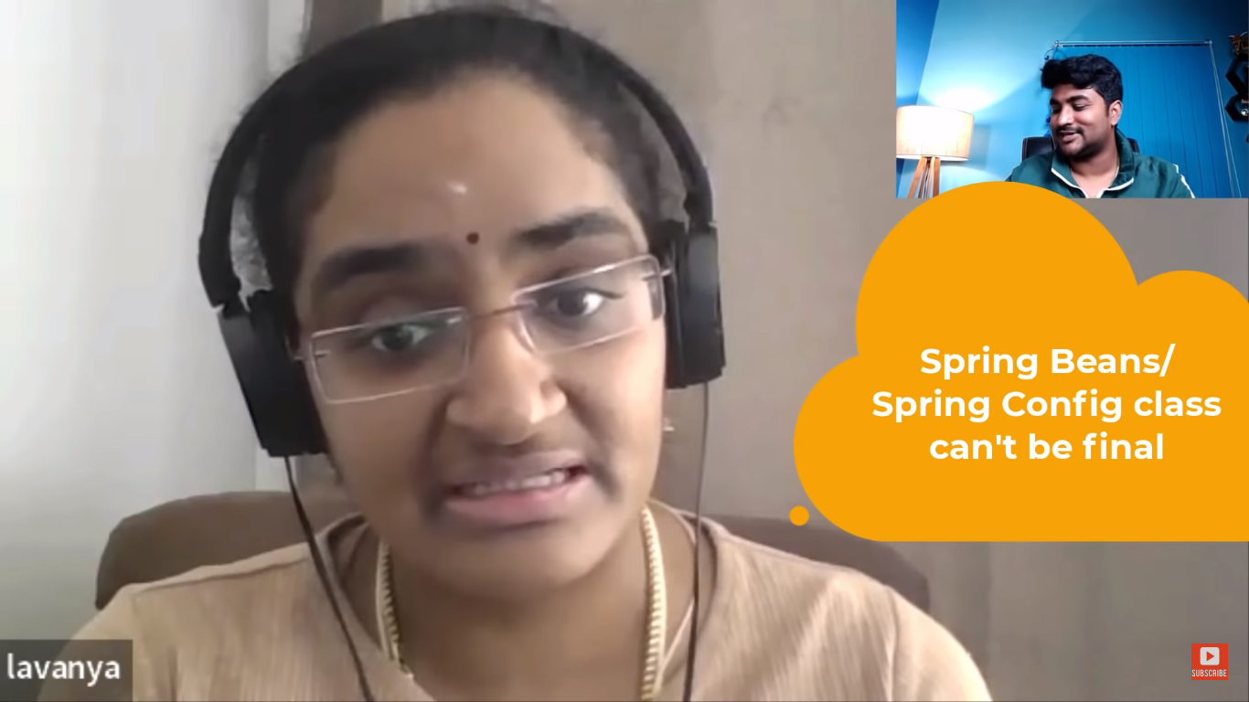

Java Config class and the methods can not be final.

Because Spring is creating Proxy of Configuration class and it is creating the Spring Beans (CGLIB library).

It creates Proxy by extending the Configuration class. So if we make the class or methods as final then Proxy cannot be created,.

6>@Bean vs @Component:

We can add @Conditional when Beans created with @Bean .

When Beans are created with @Component then they are condition less

<https://medium.com/javarevisited/what-is-difference-between-component-and-bean-annotation-in-spring-bffdad0ab899#:~:text=%40Bean%20is%20used%20to%20configure,beans%20in%20the%20application%20context>.

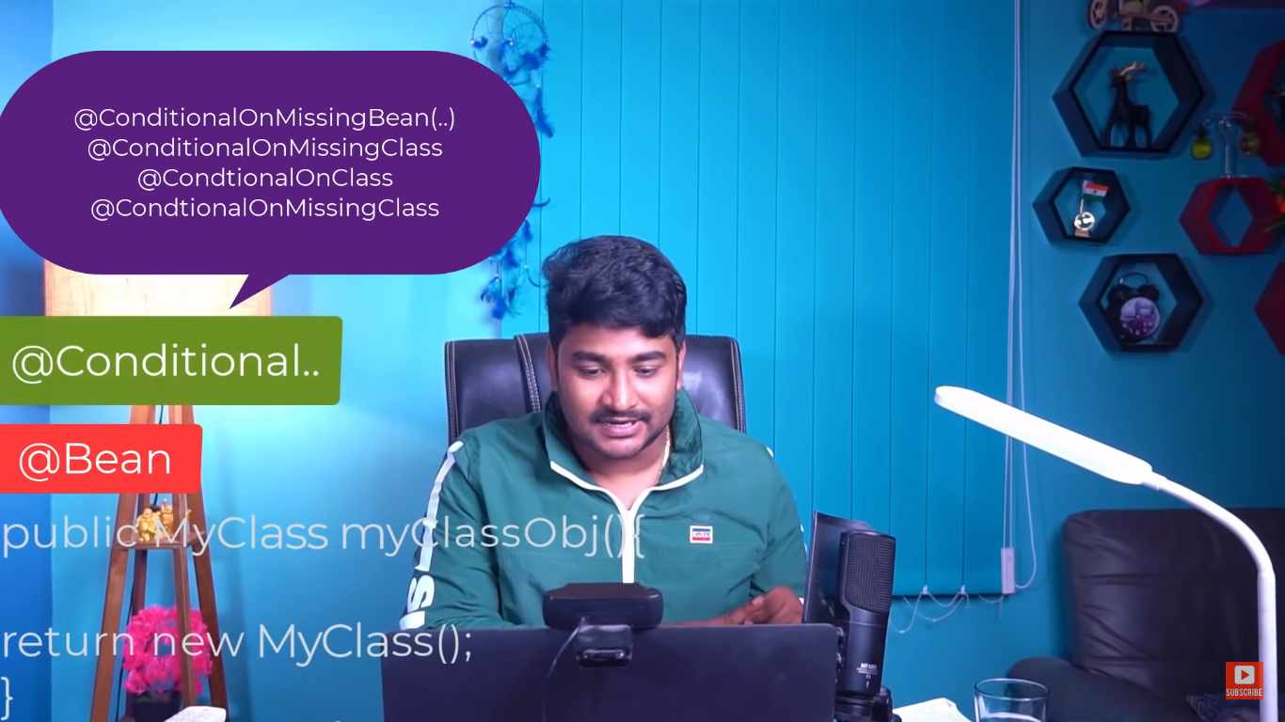

7>BeanFactoryPostProcessor & BeanPostProcessor :

Customizing Metadata

Bean definitions are loaded but bean is not instantiated.

If we want to do something after Bean is initialized then we have to do BeanPostProcessor.

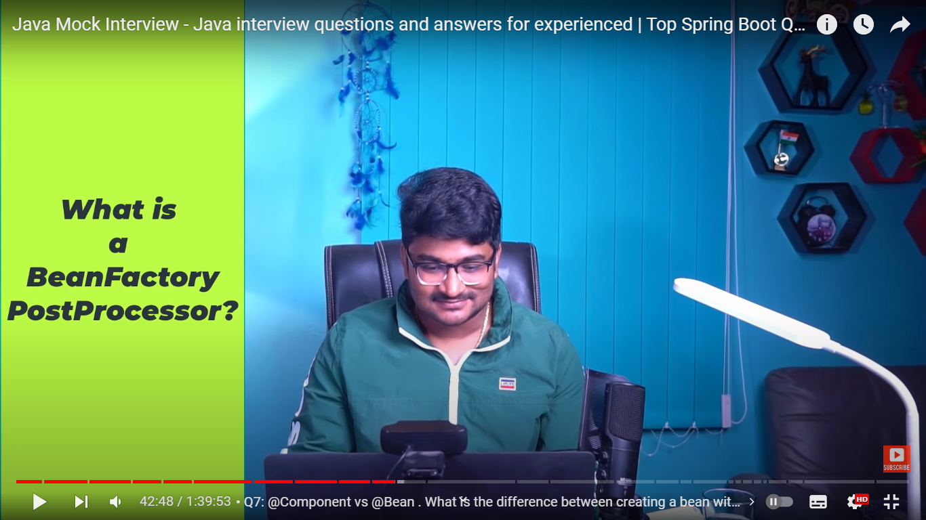

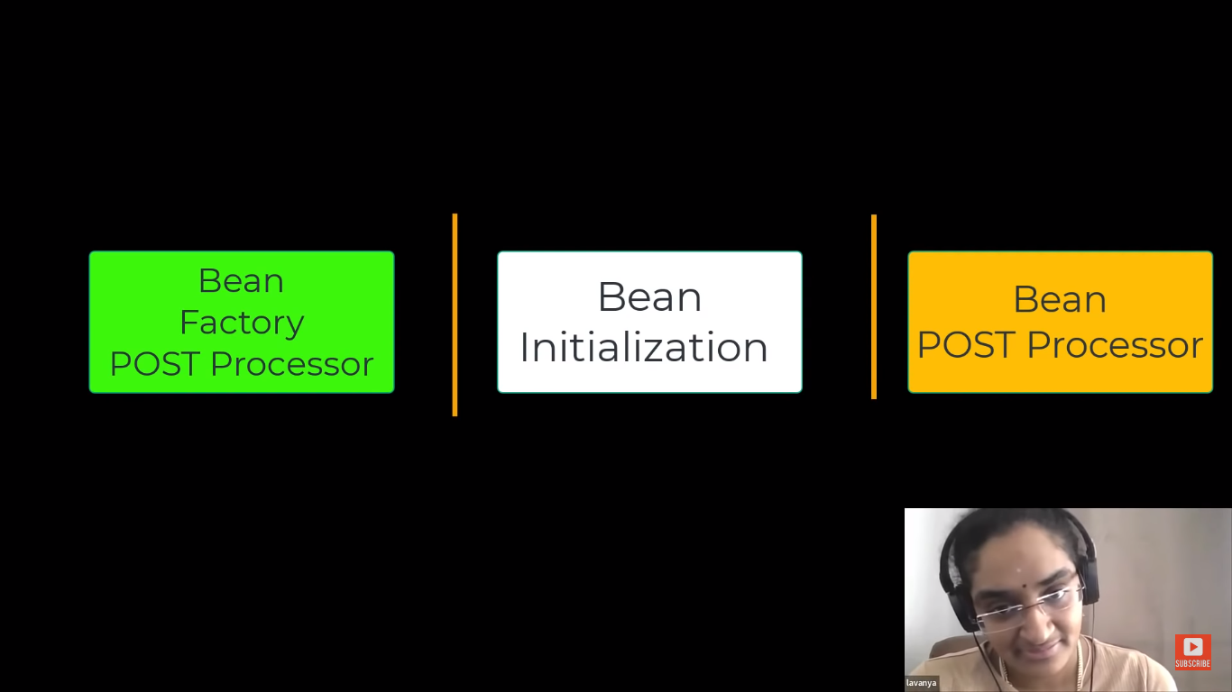

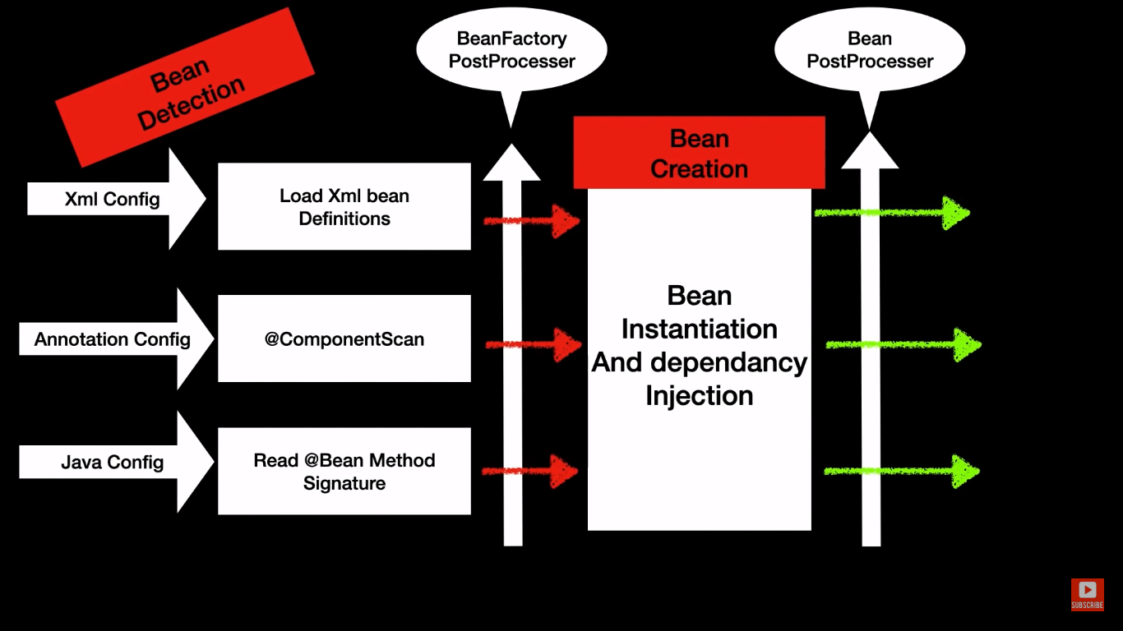

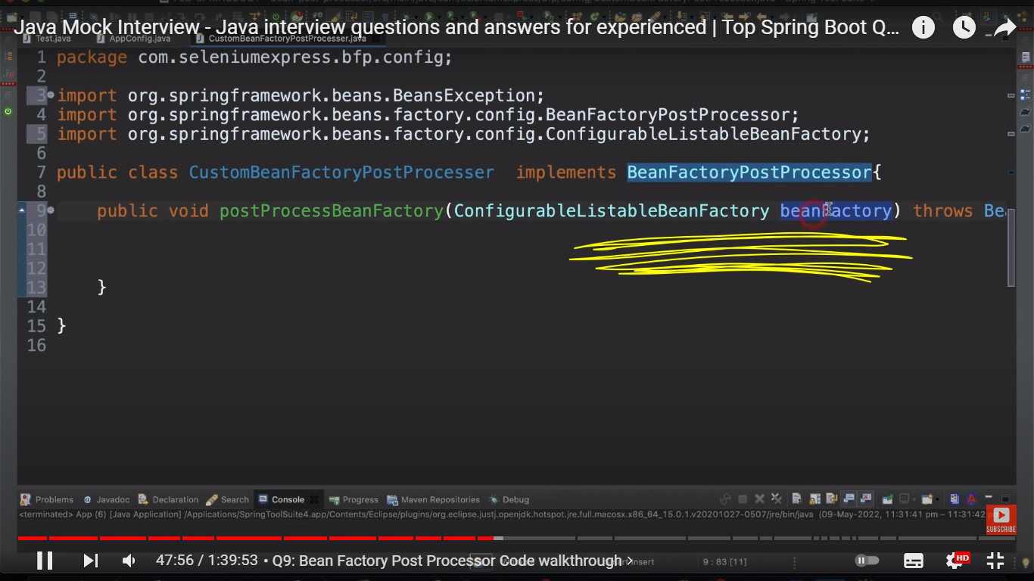

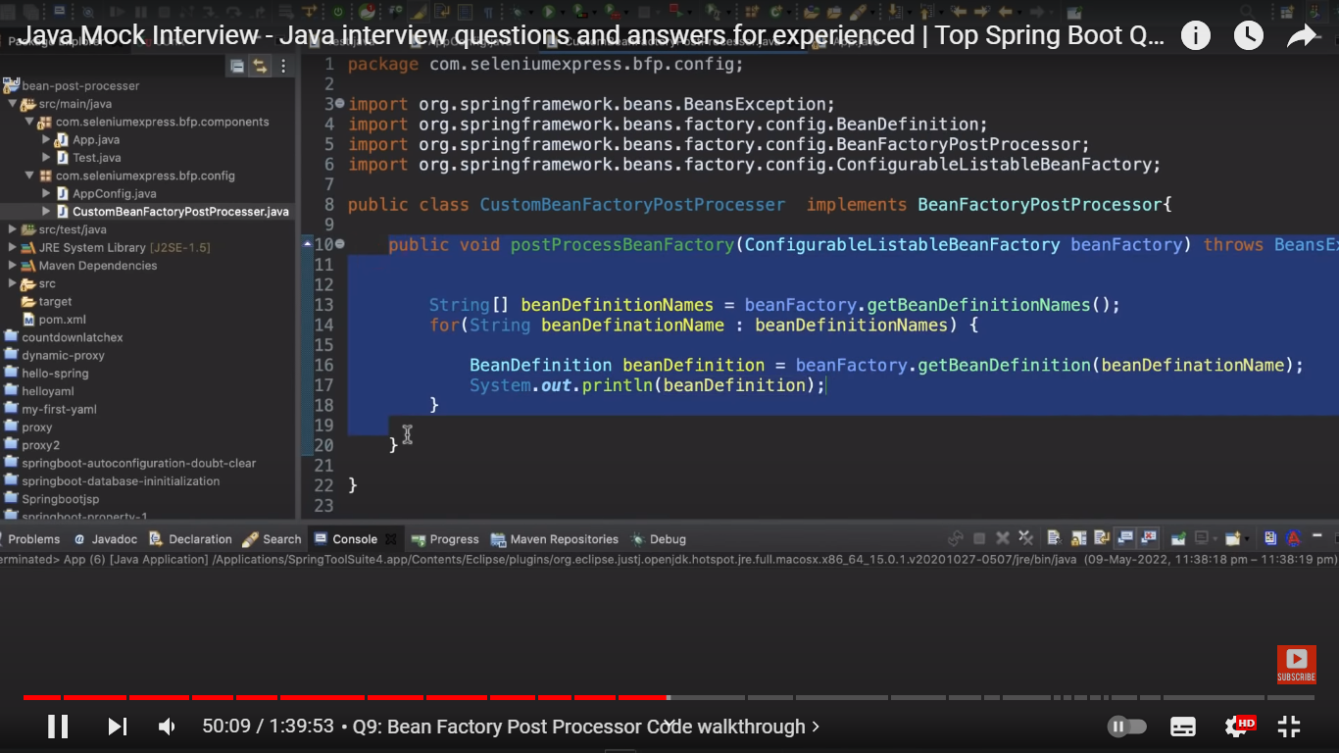

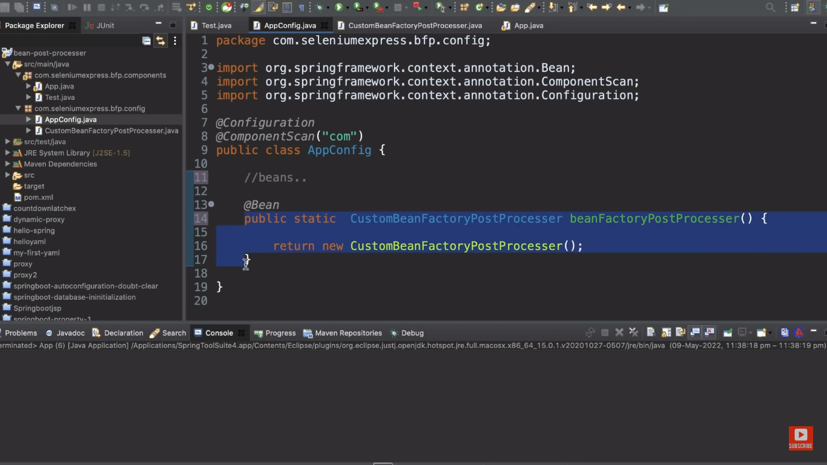

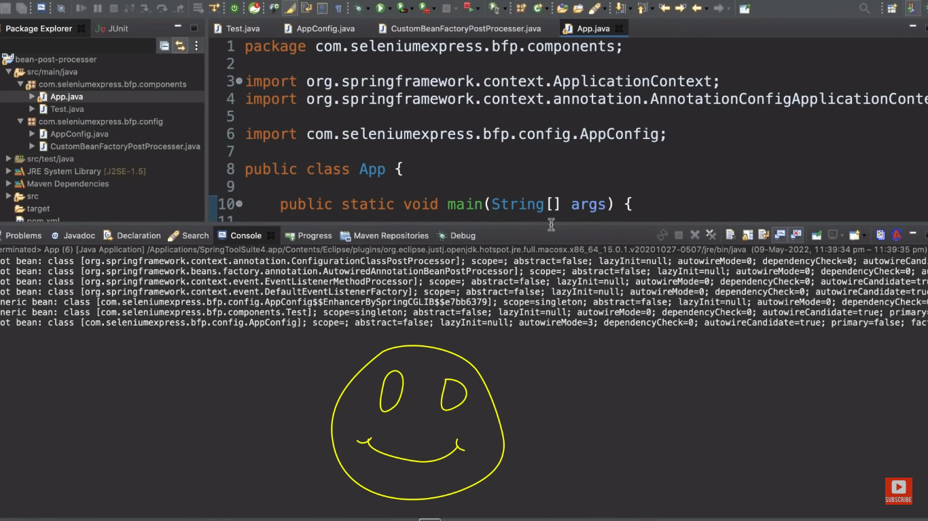

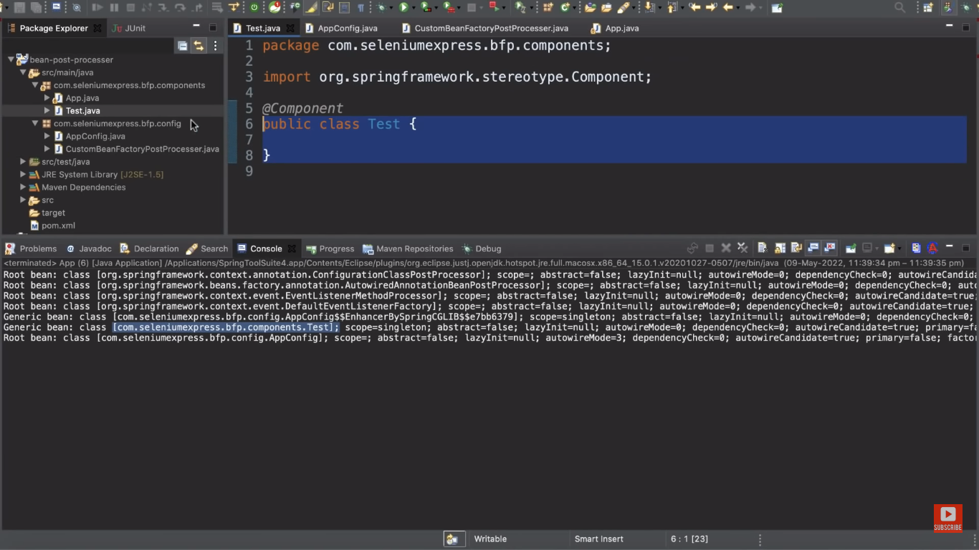

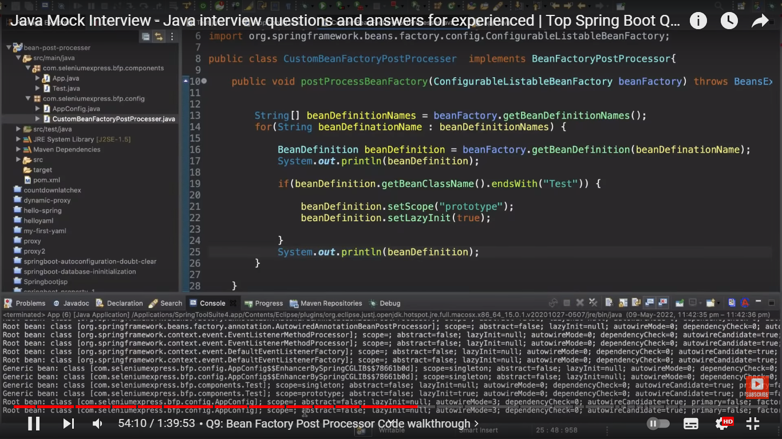

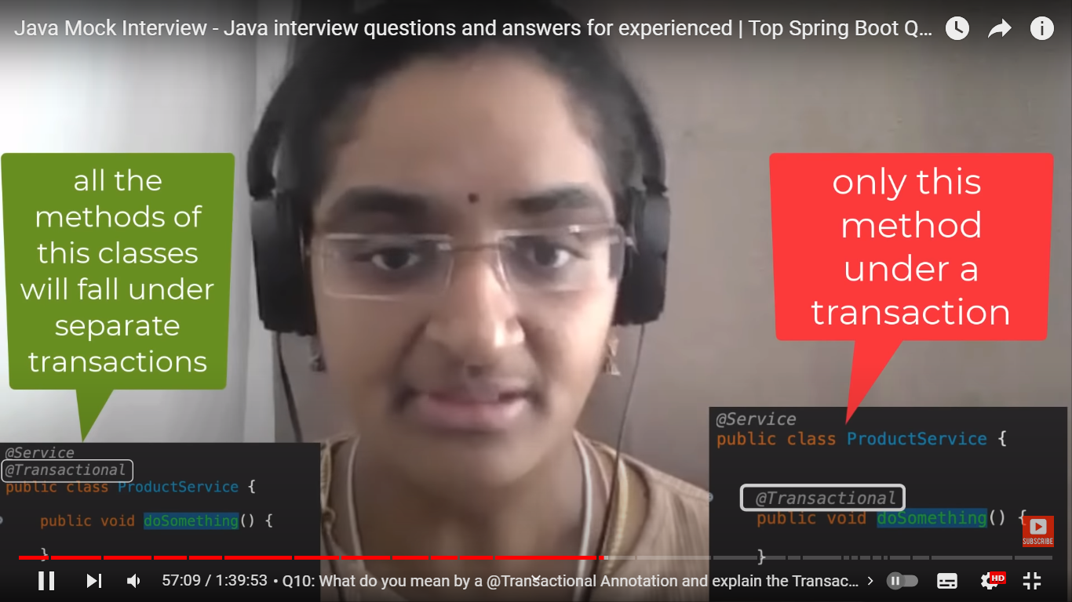

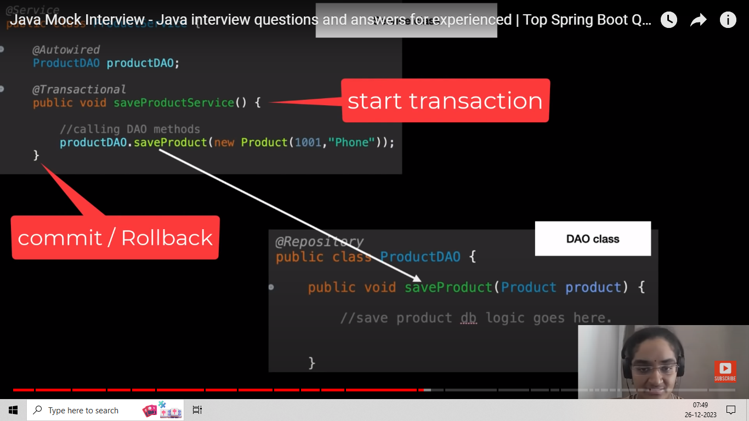

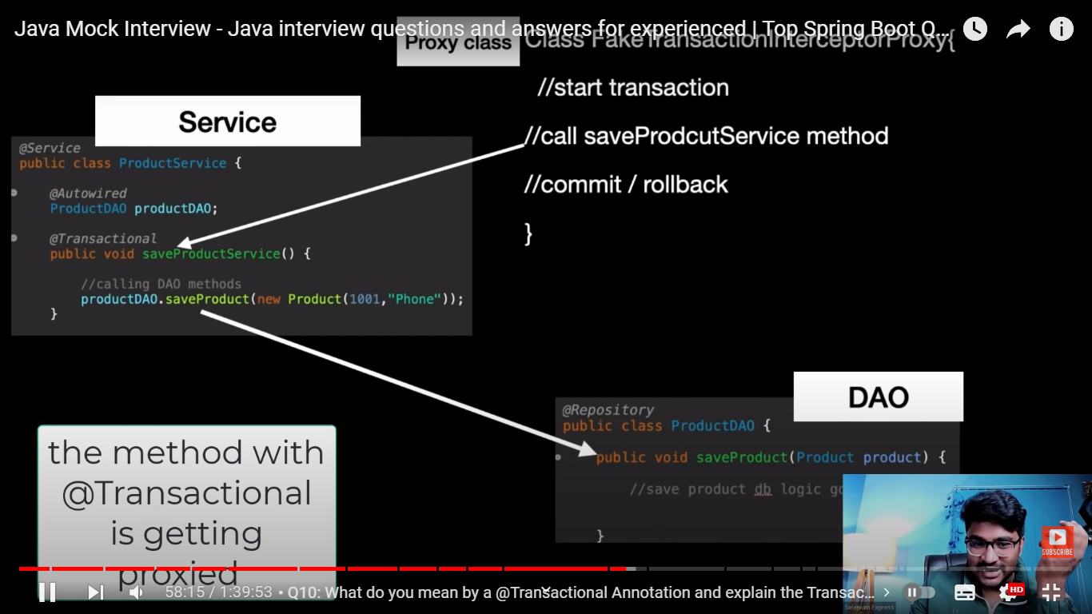

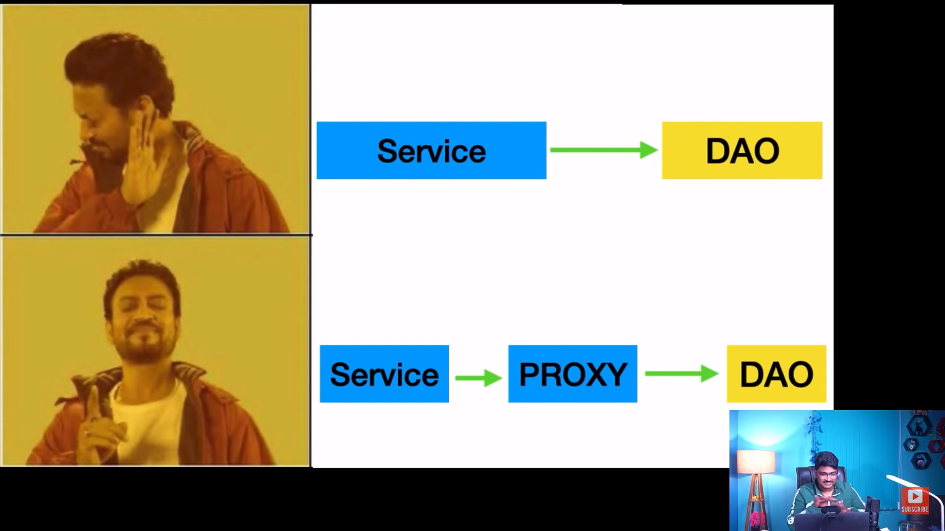

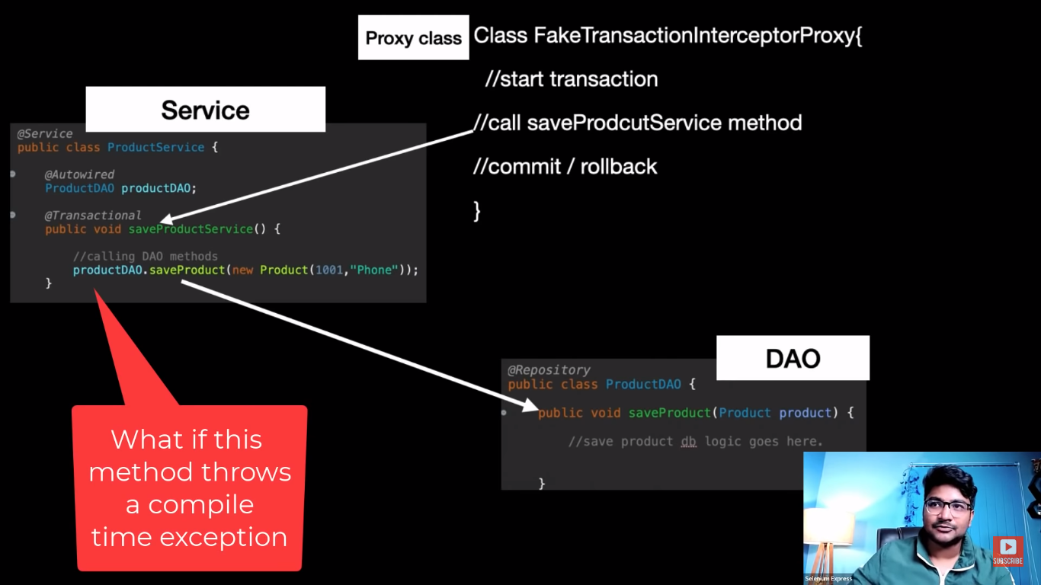

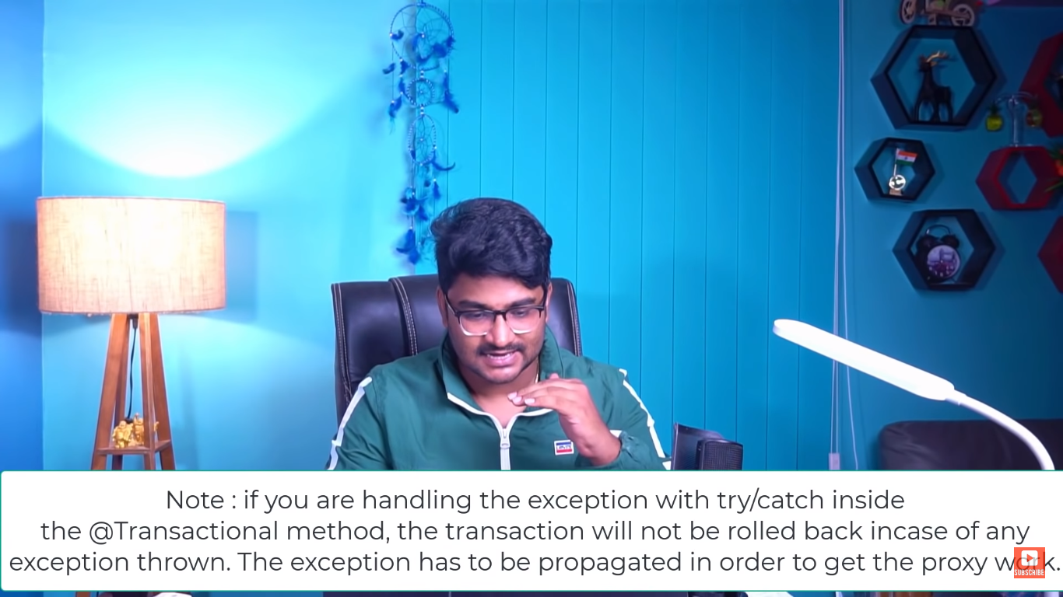

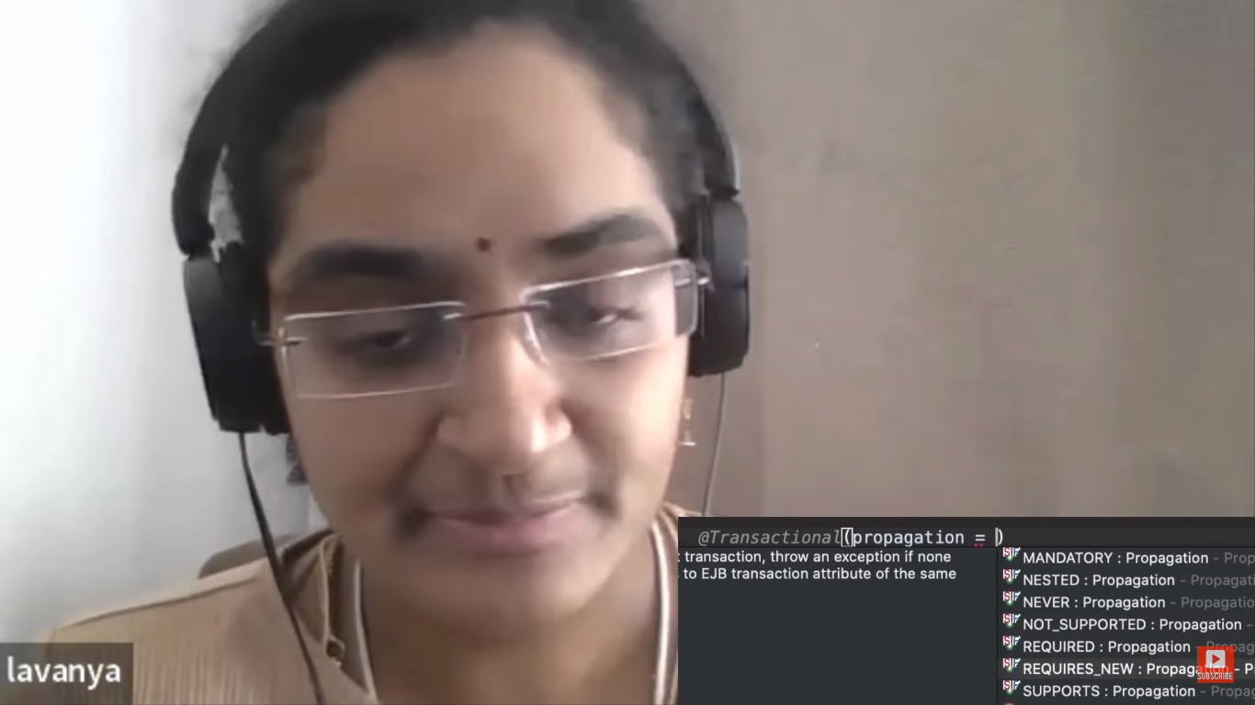 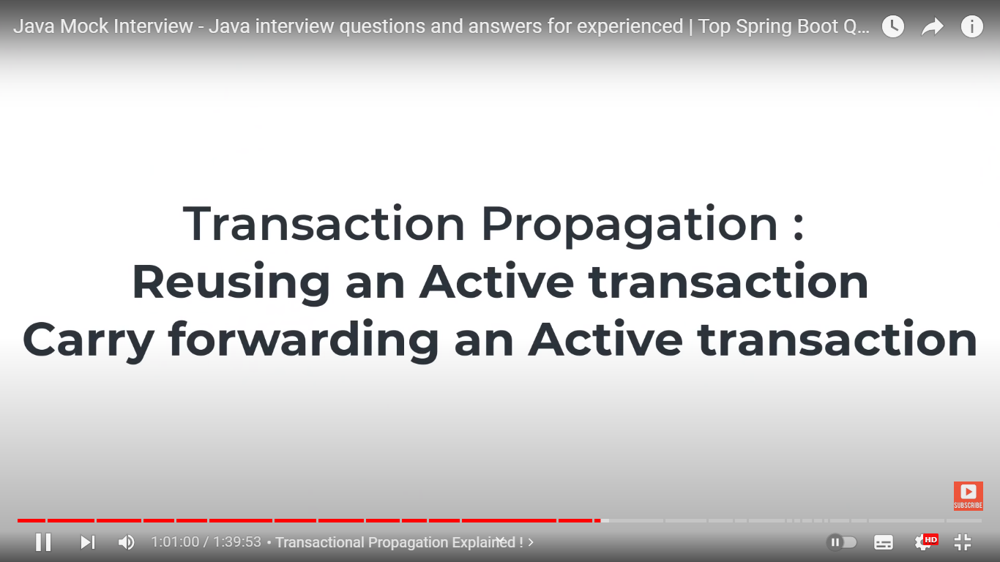 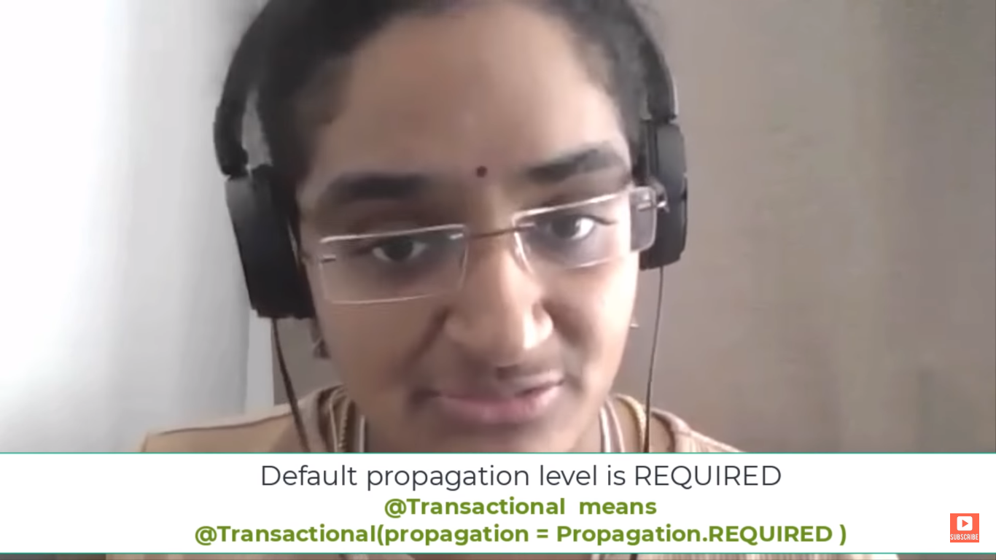 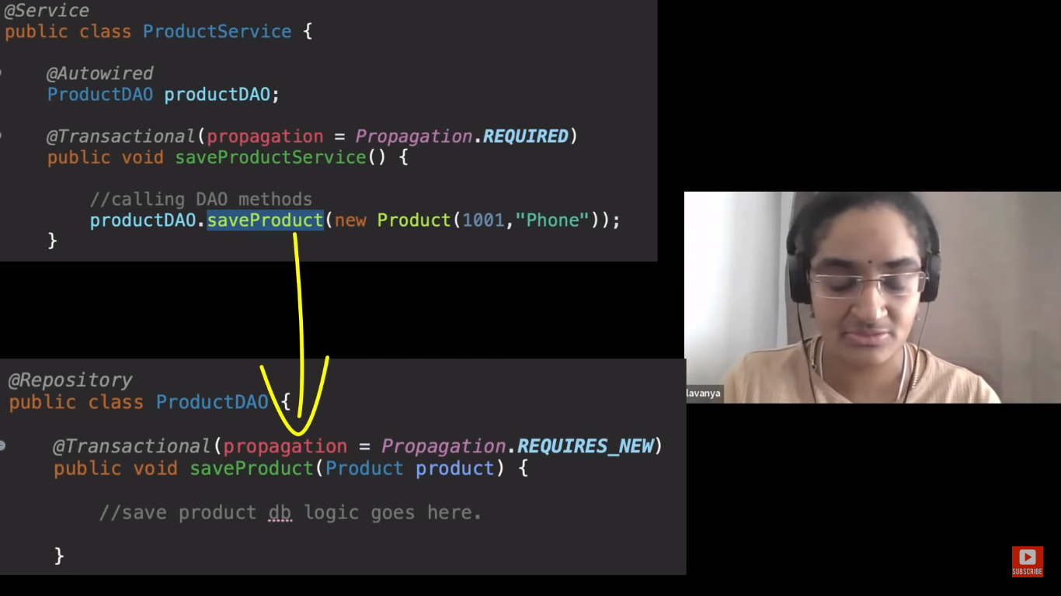

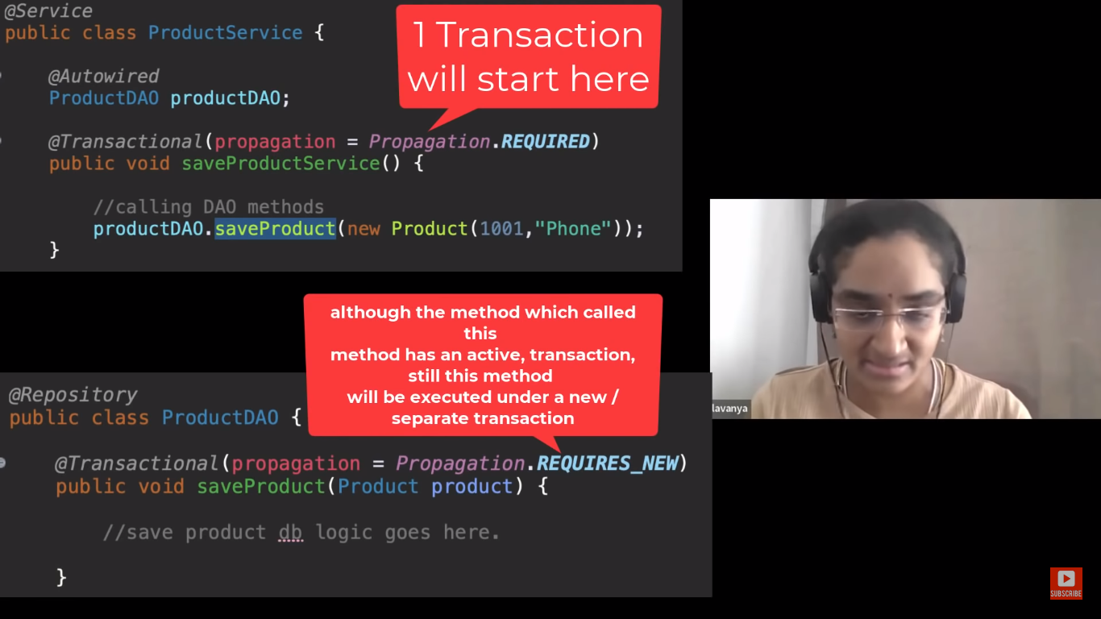 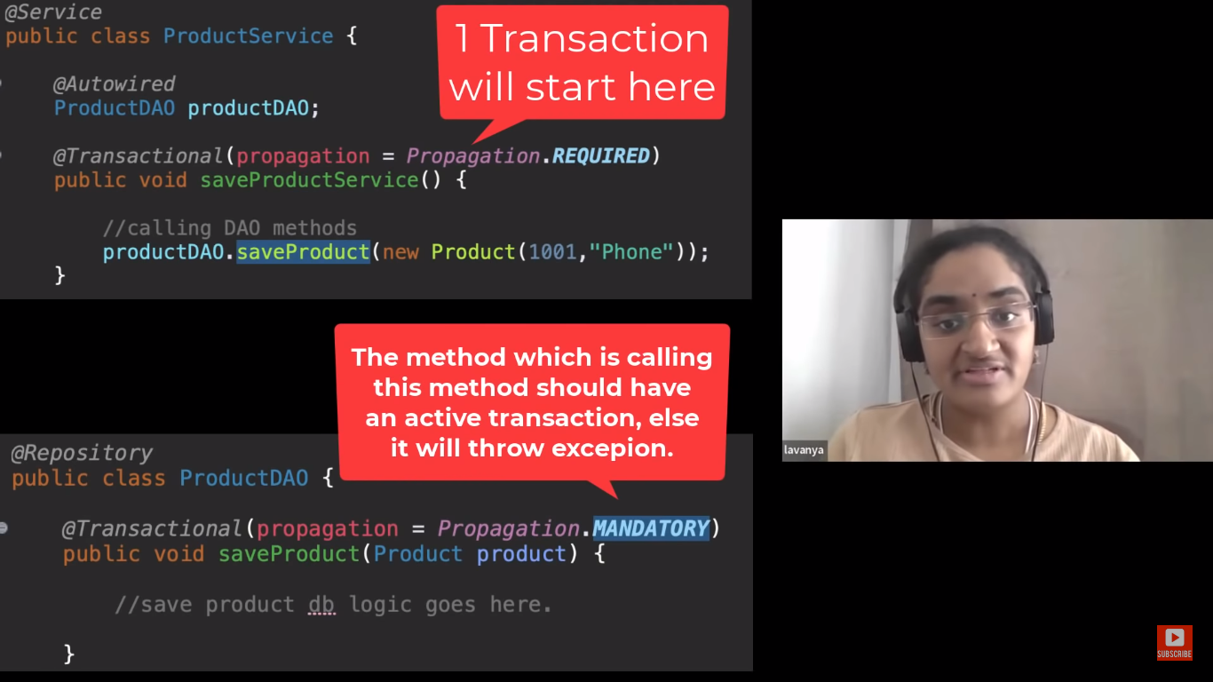 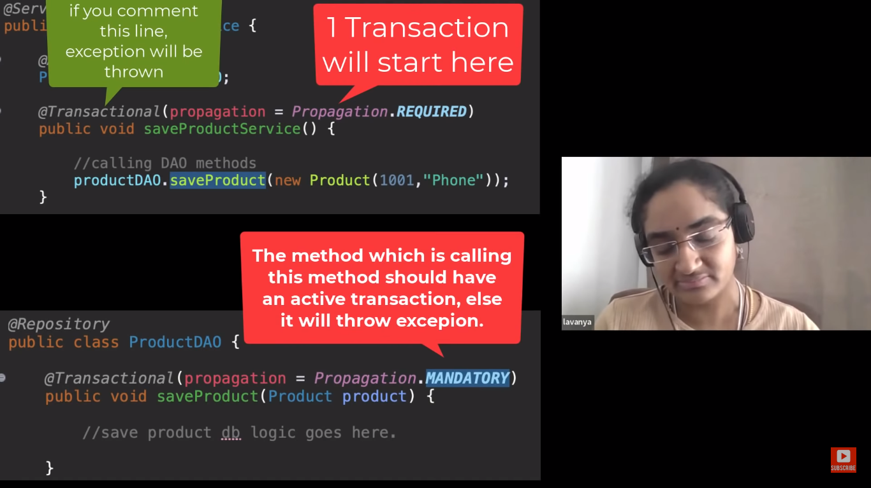 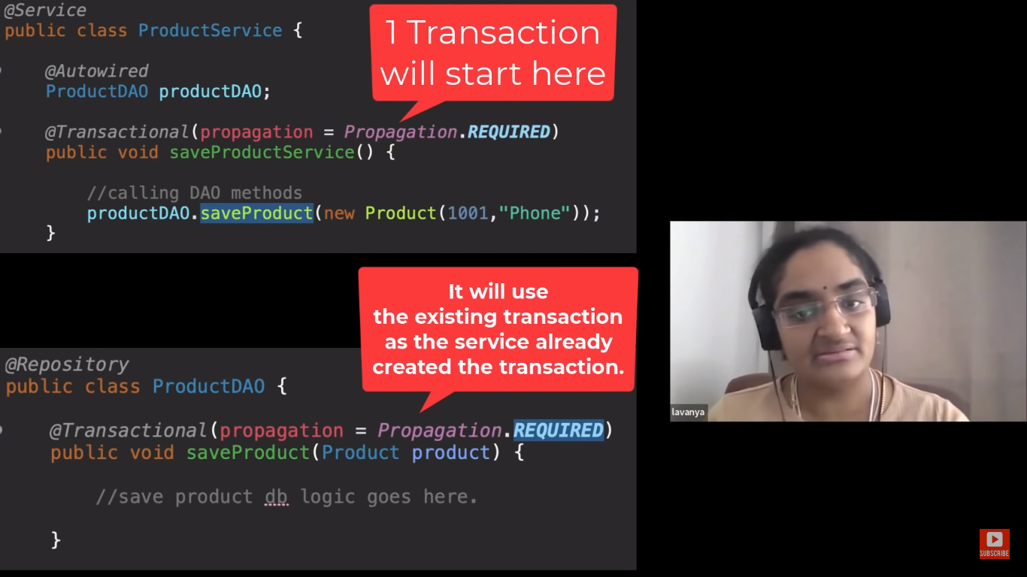 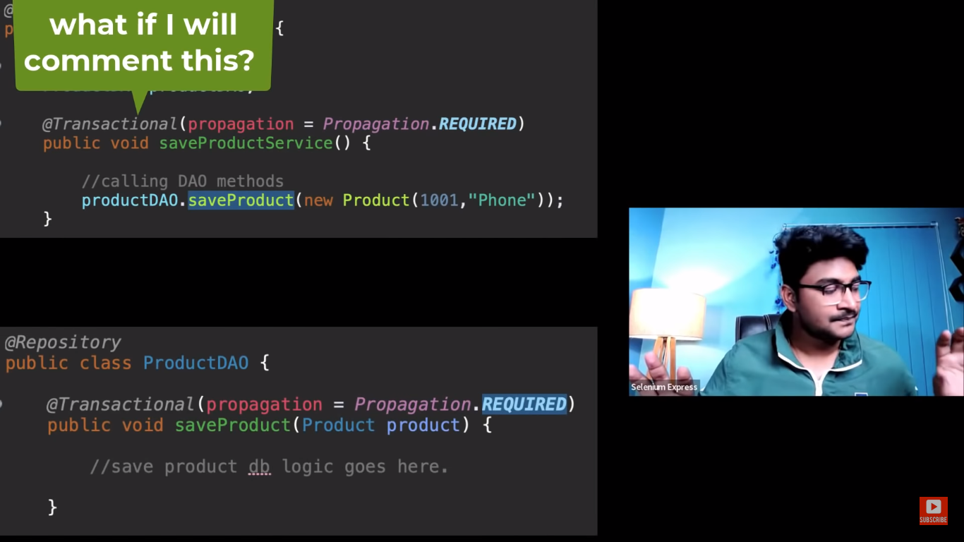

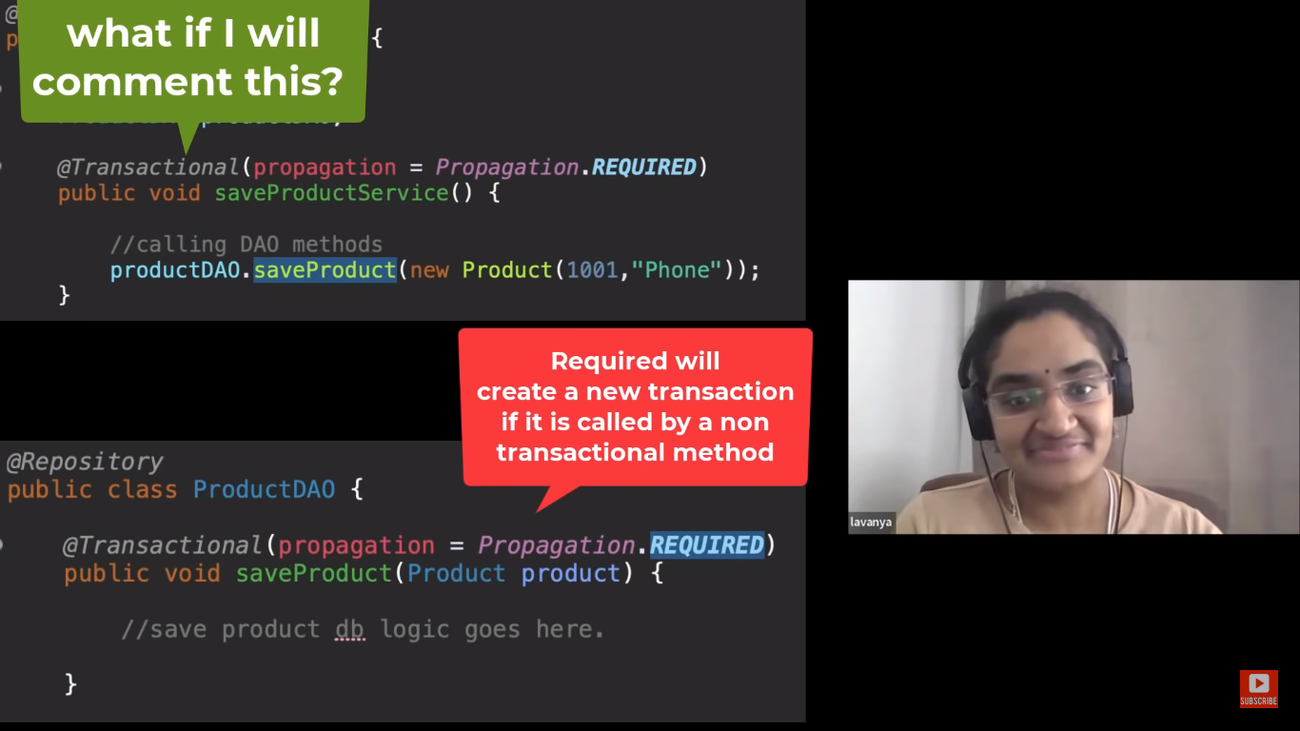 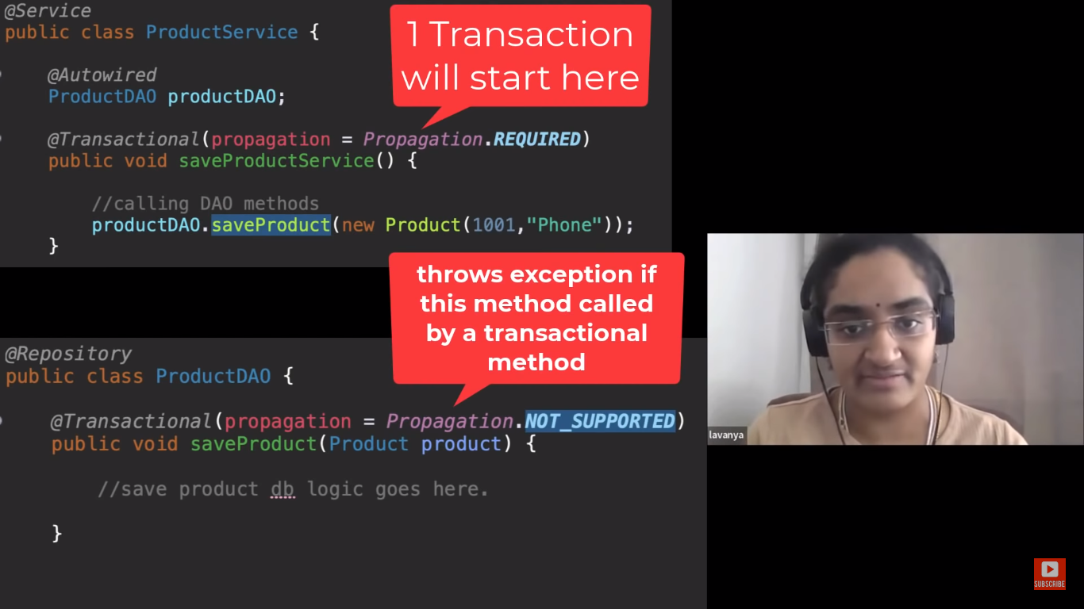 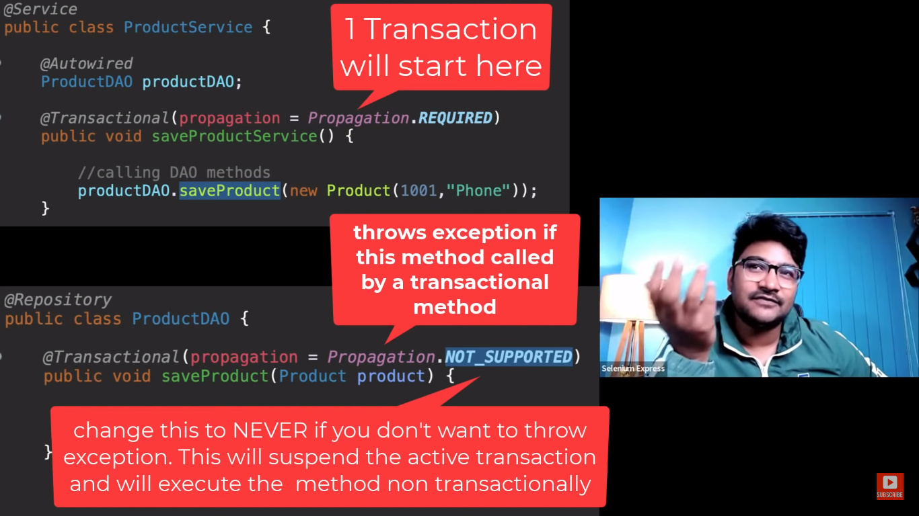



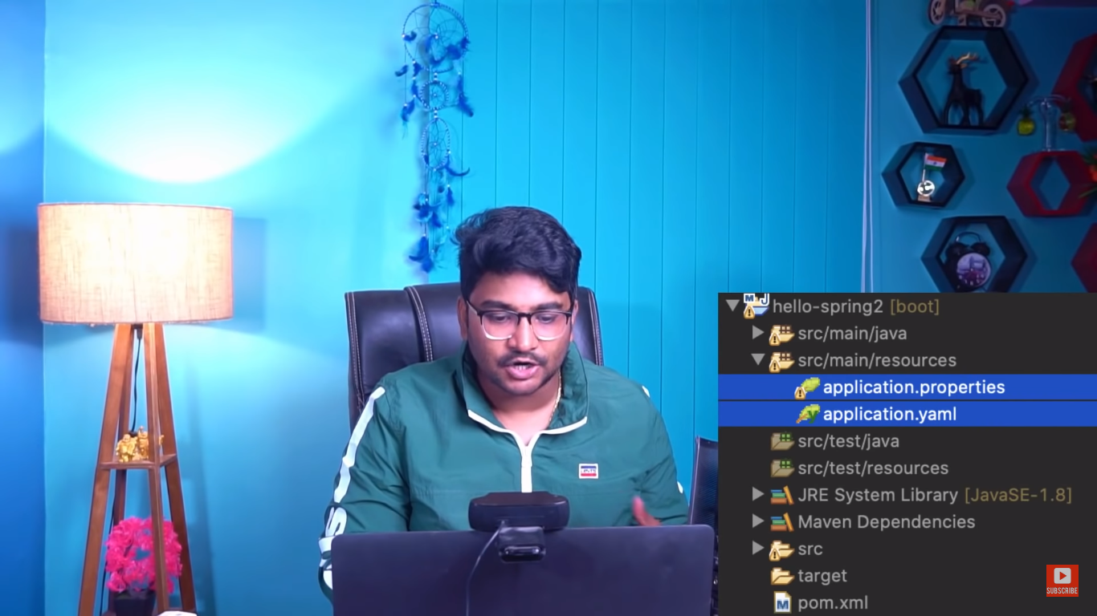

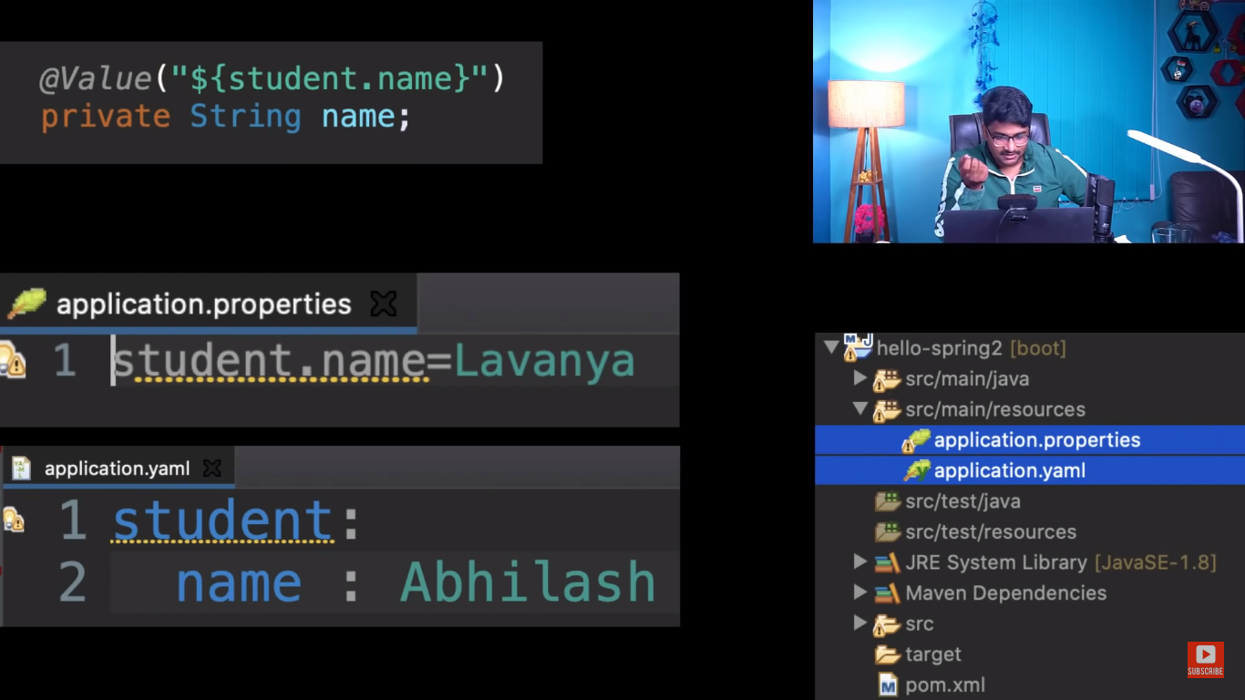

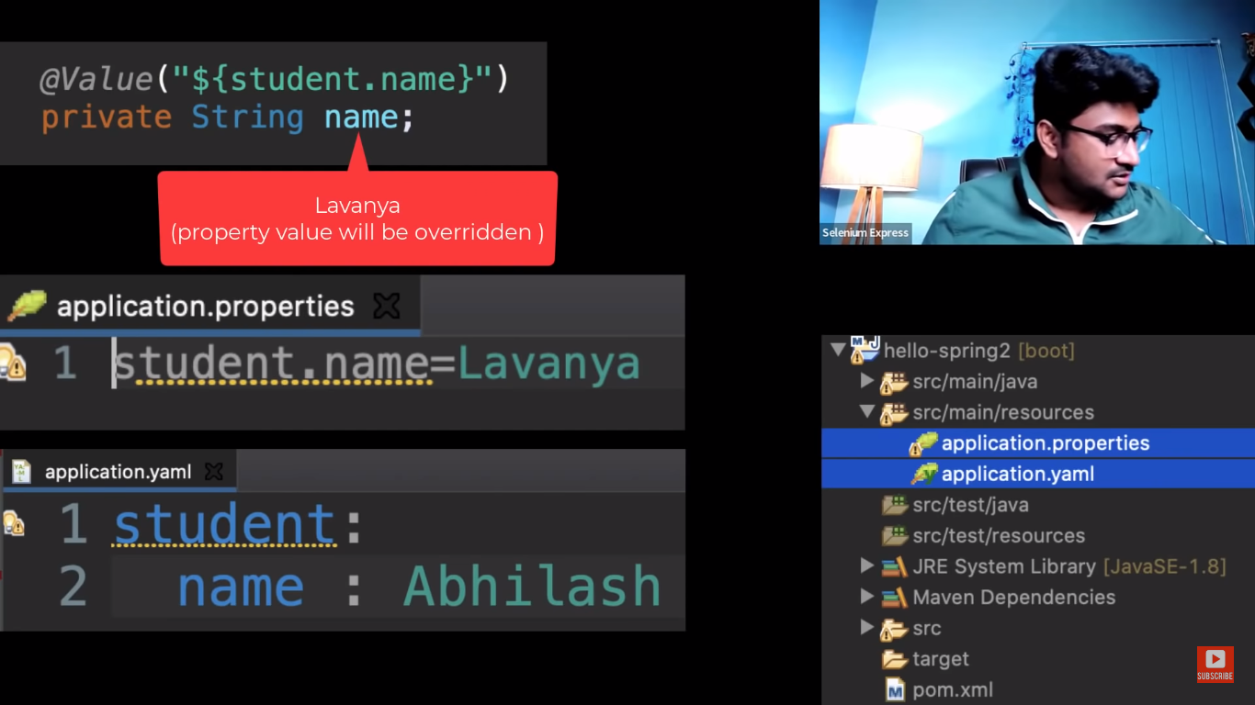

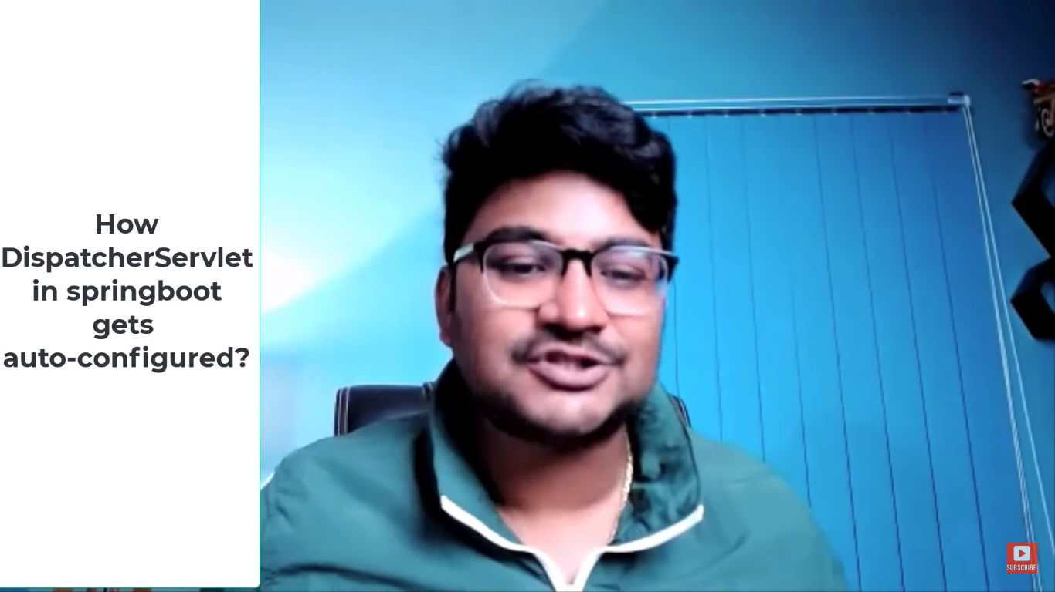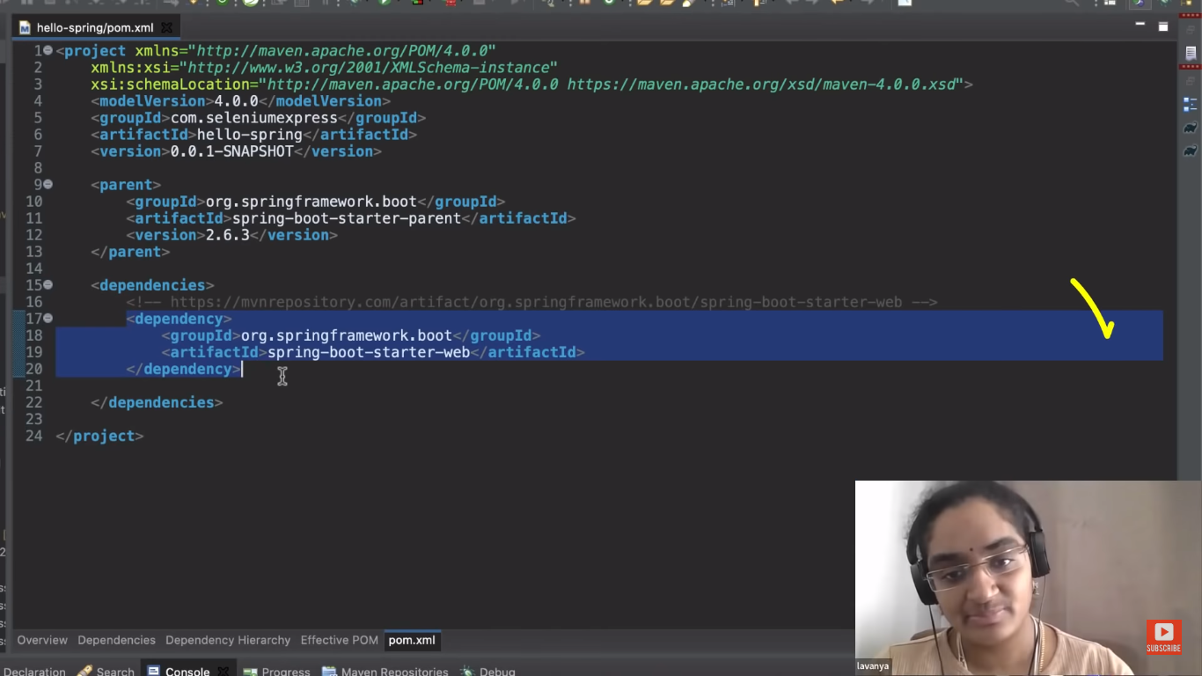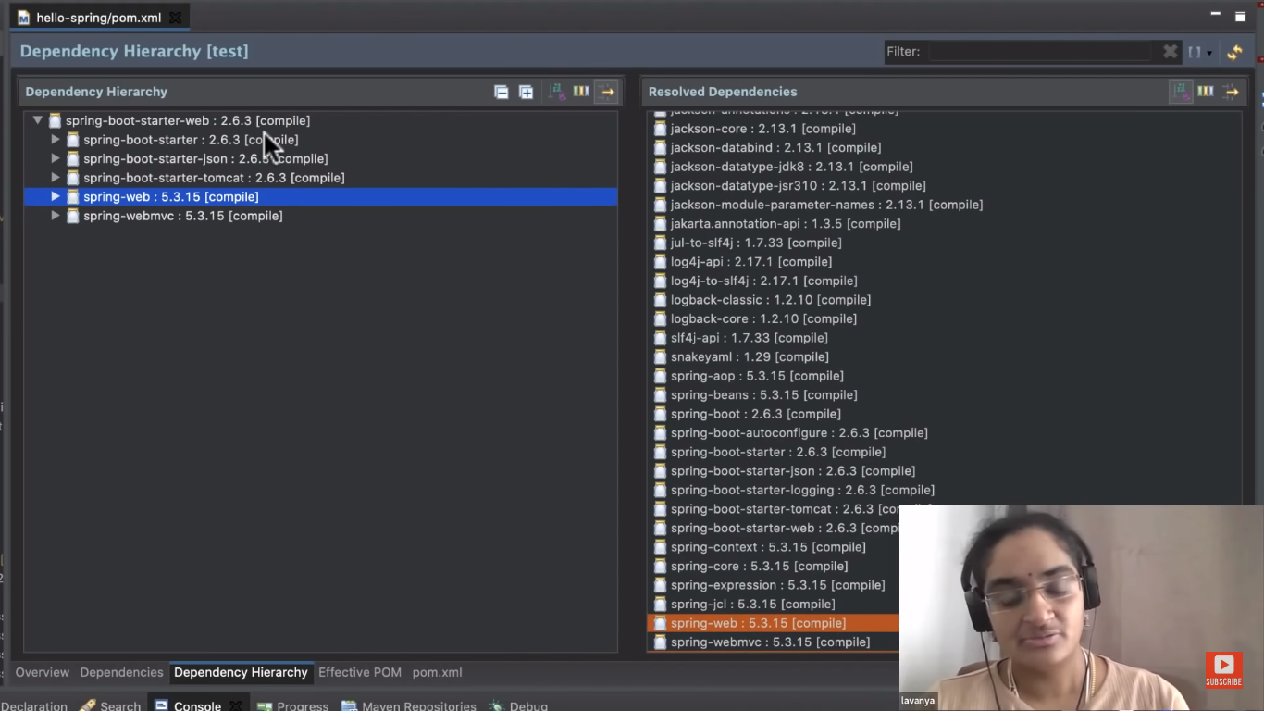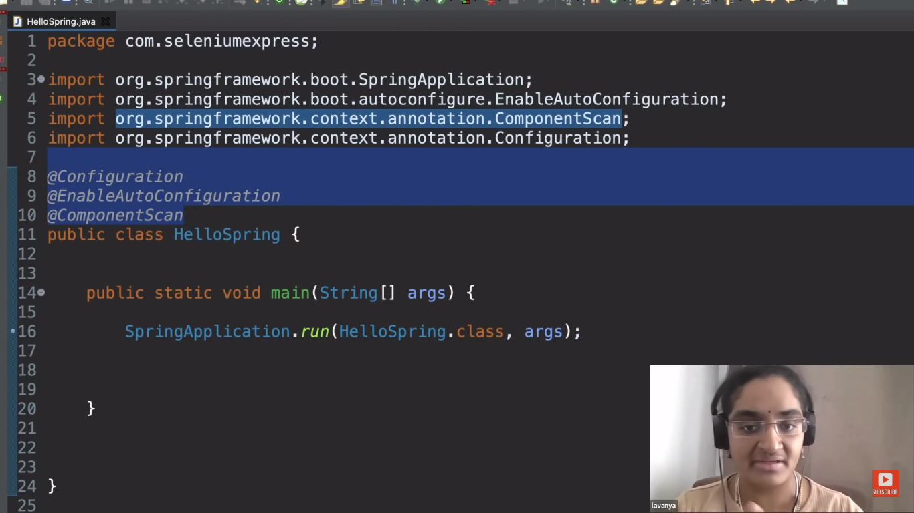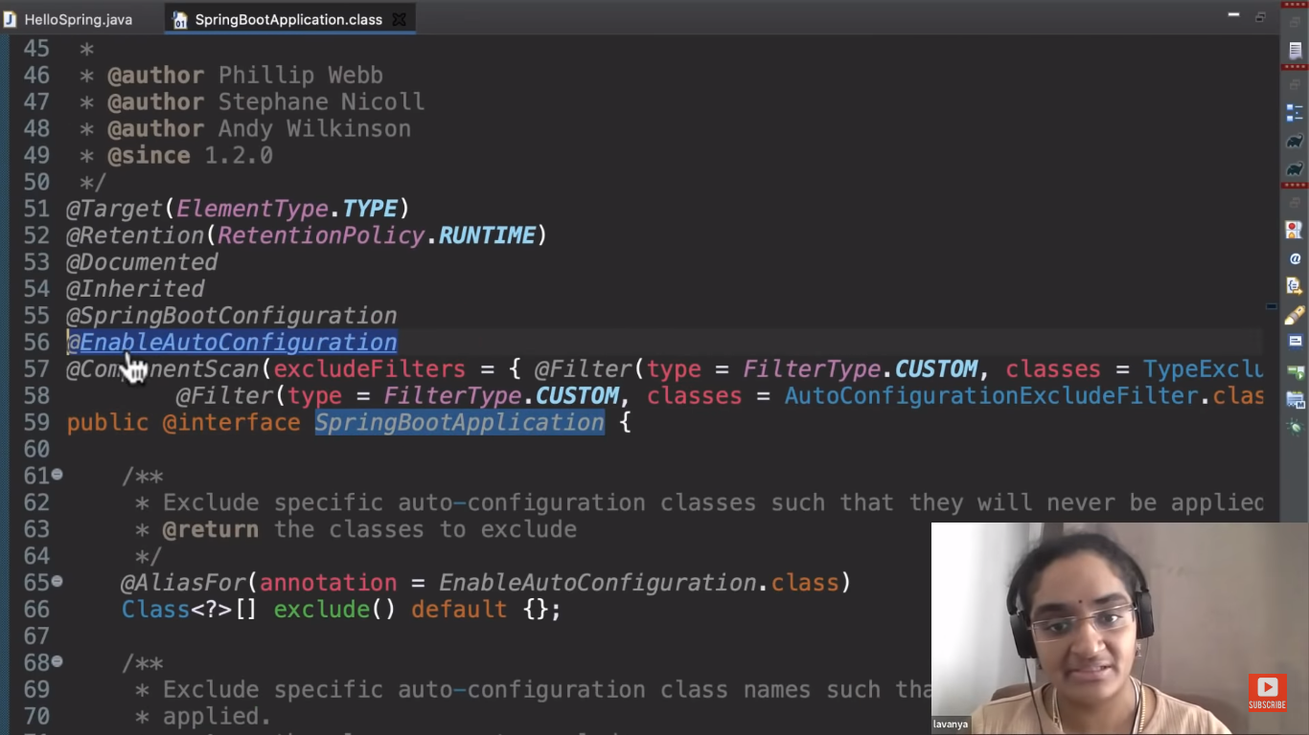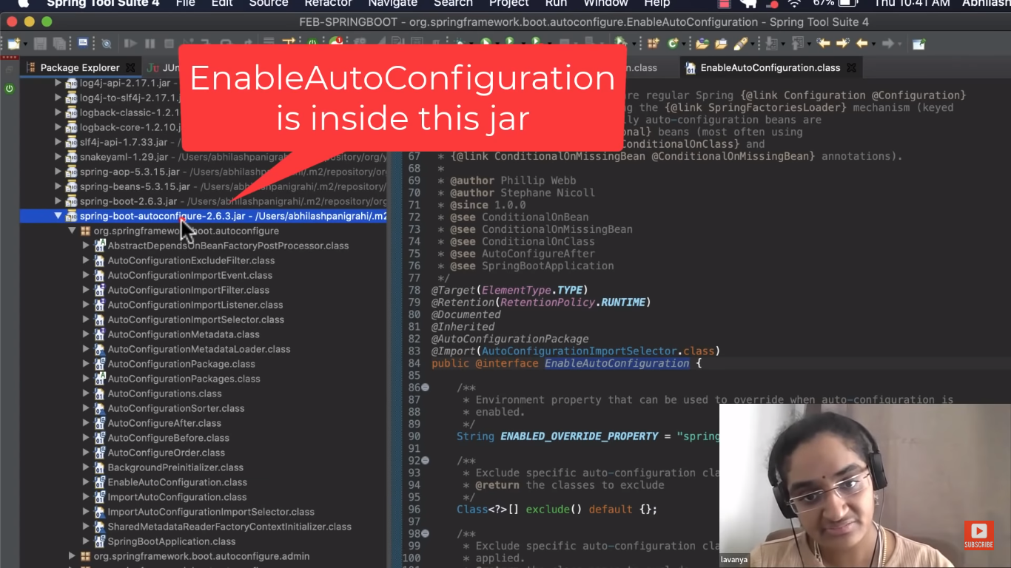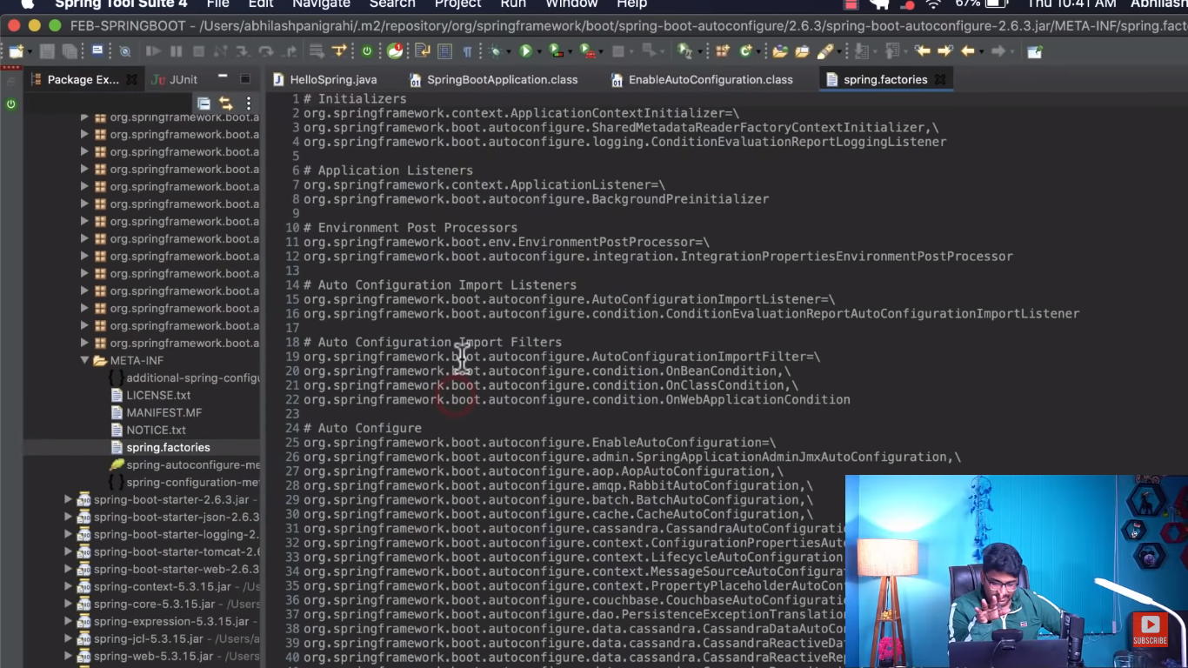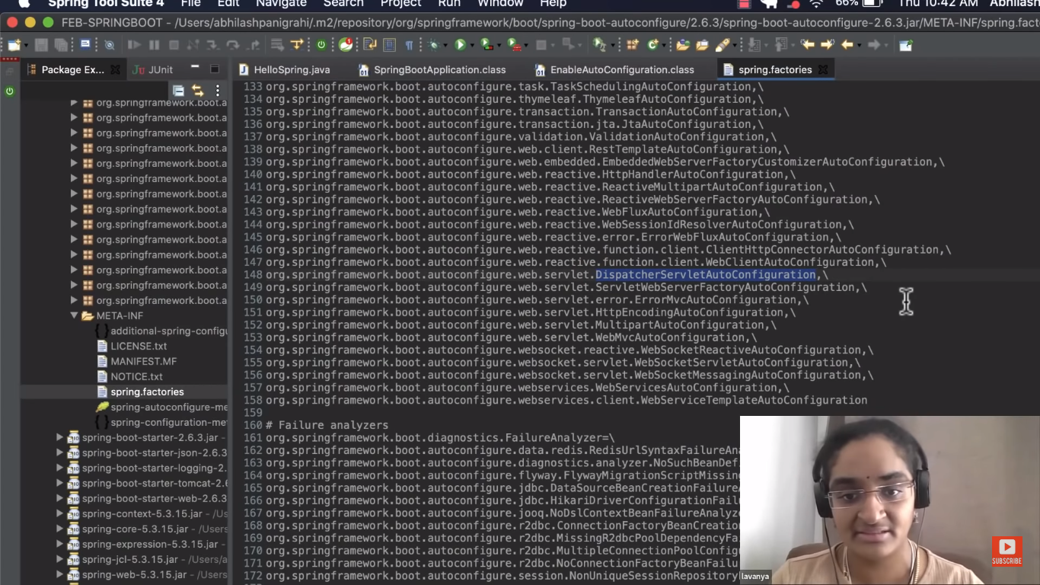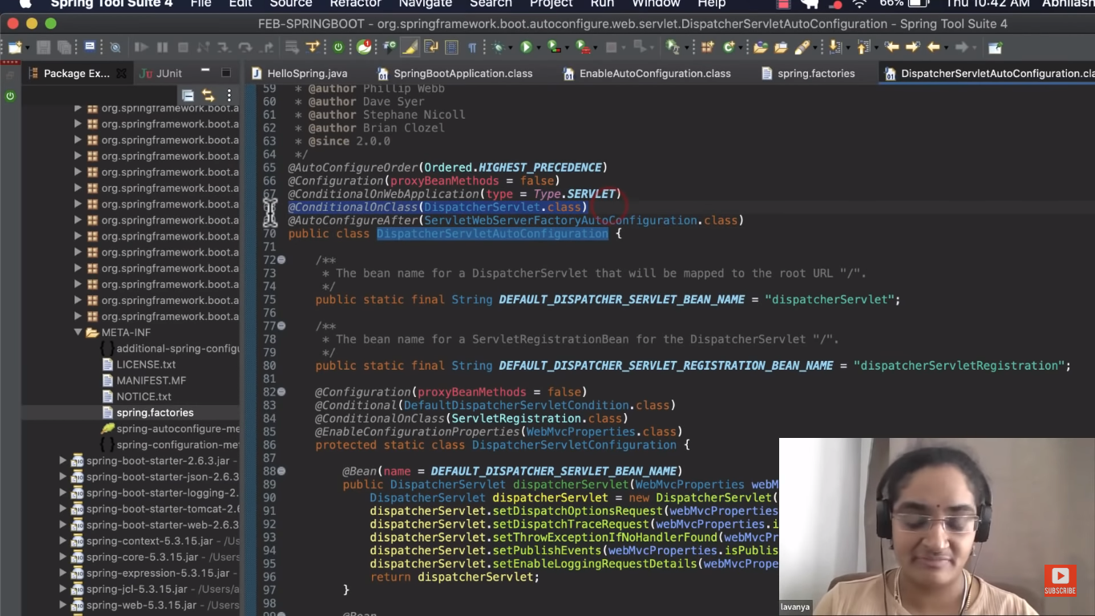

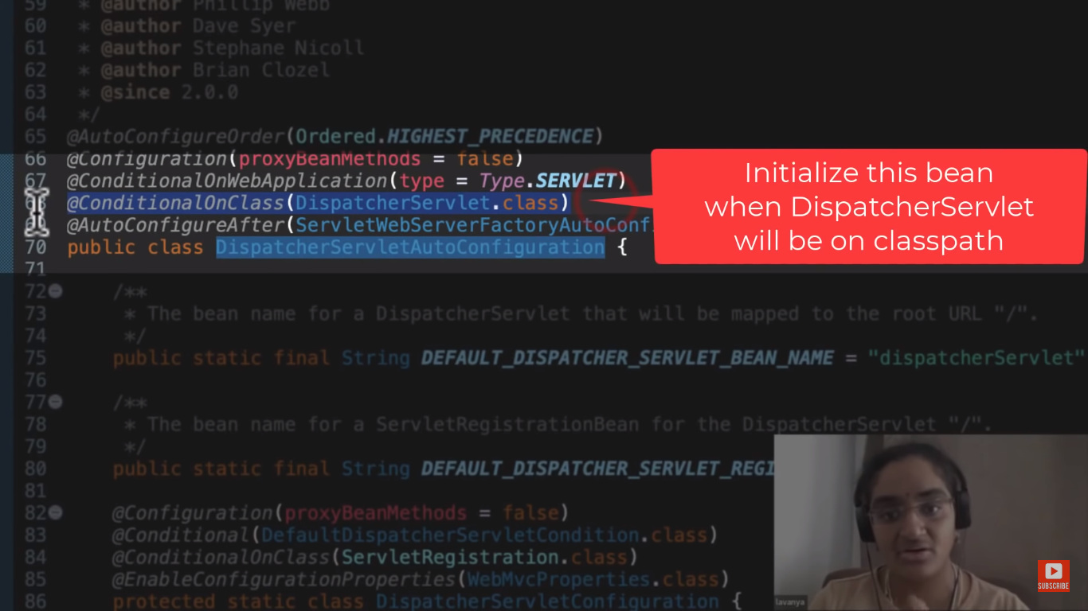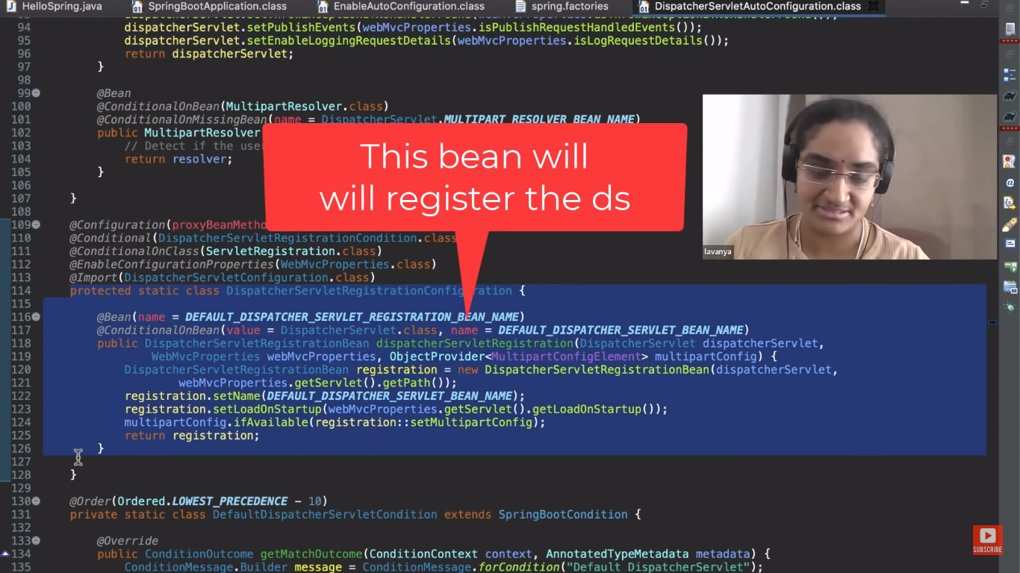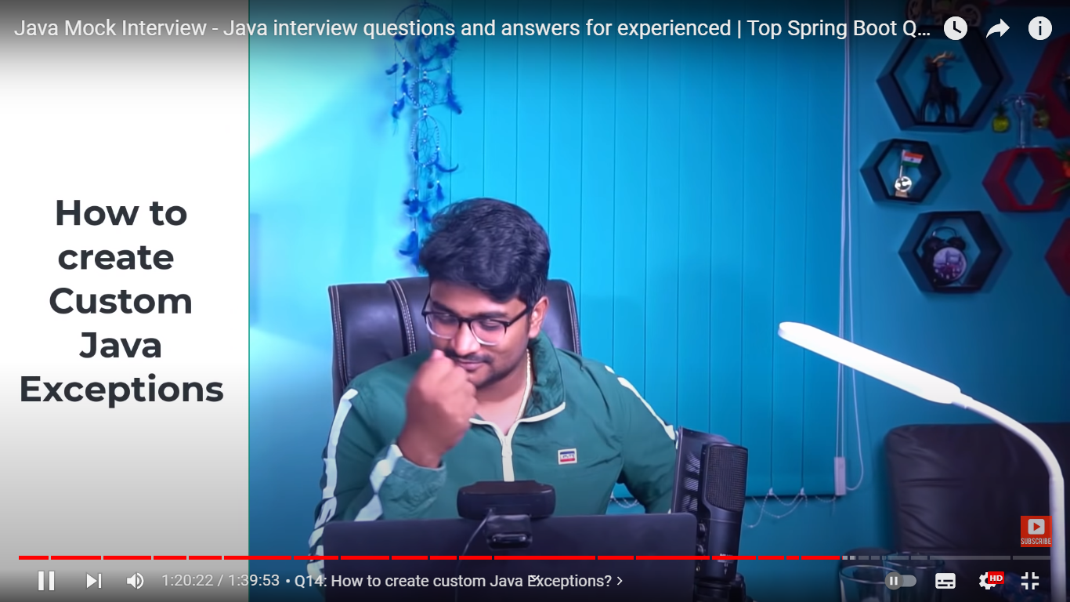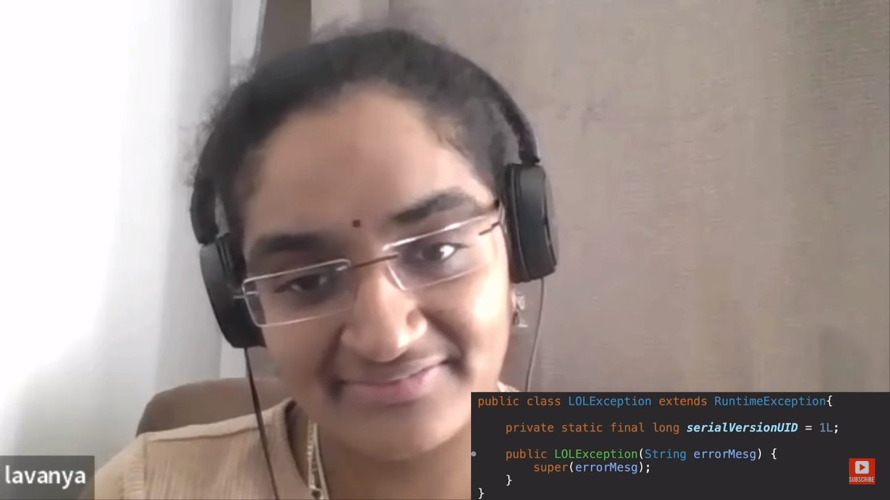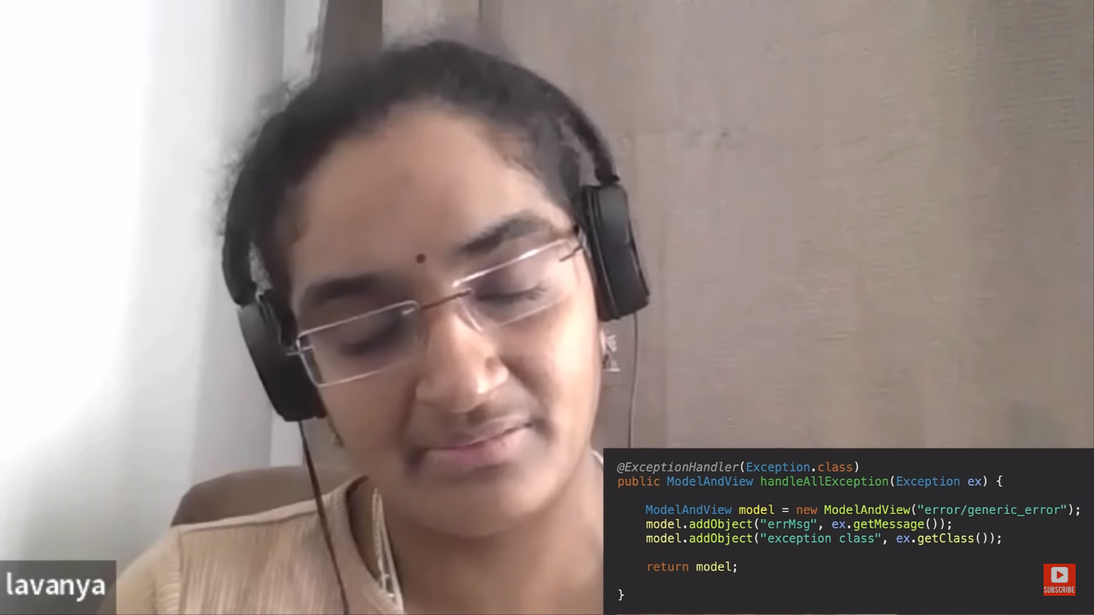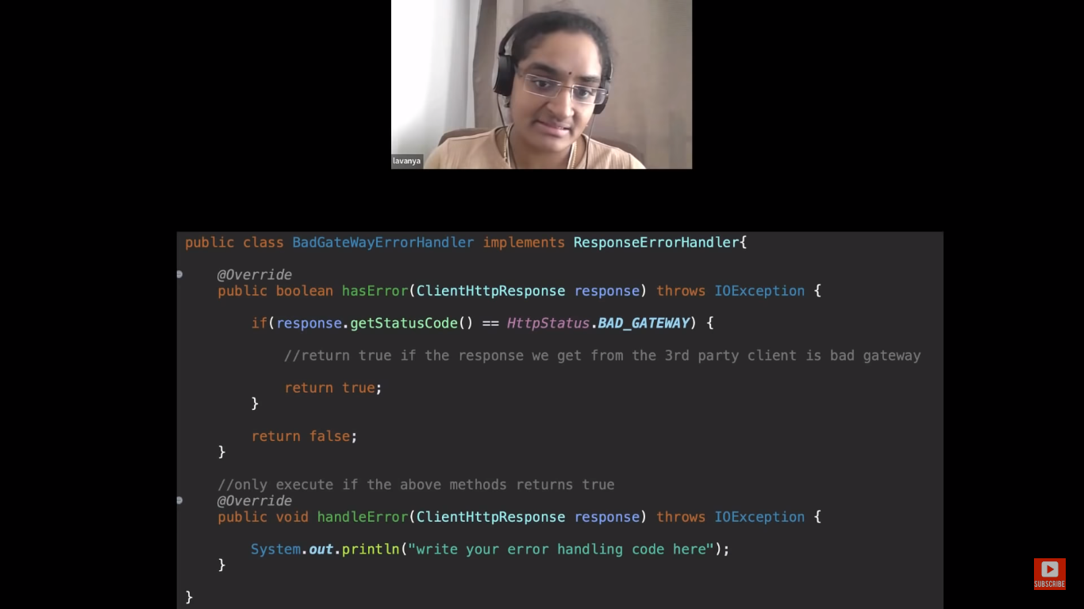

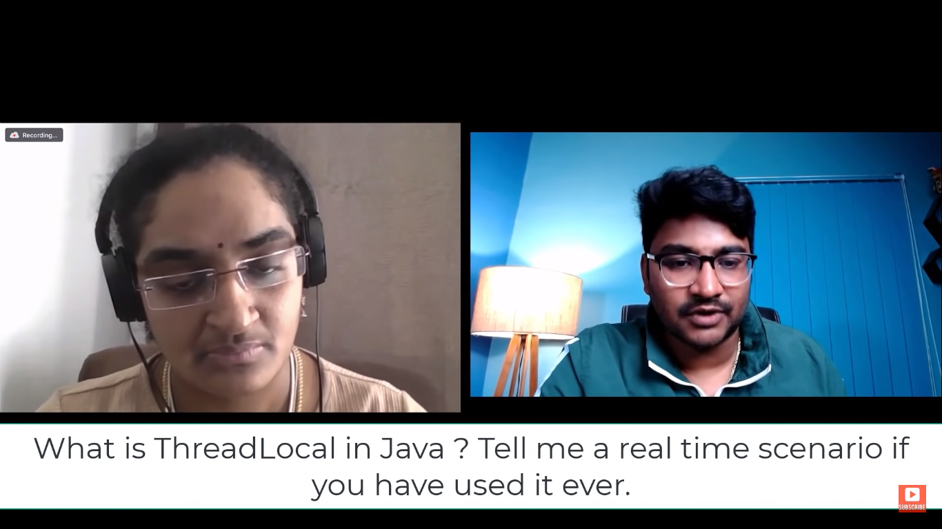

Thread Local is the memory available to each Thread in java.

No other thread can see it

Useful in Spring Scopes

Flow of Spring Security:

Request hit the Web server . Server creates a Thread.

First it goes through Authentication filter -> has User Name Password and other details like IP address and Certificate of user.

Filter creates a token . isAuthnicated() method -> initially has false.

Request in then handed over to Authentication Provider manager.

This manager decides to which Authentication Provider it should redirect this request.

We can have different providers . default is UseNamePassword Authentication Provider.

So token is handed over all provider .Every provider has supports() method. UserNamePassoword Provider returns true.

Then UserNamePassoword AuthenticationProvider hands over request to UserDetailsService to loadUserbyUsername.

Load all user details roles etc

Also we should have password encoder

Validate the User and isAuthenticated() is now true.

Then request goes to SecurityContextHolder which has SecurityContext.

And in this context Username password Authictaion token is stored which has isAuthenticated(0 as true.

This SecurityContext is stored in ThreadLocal.

So every web request has its own threadlocal and hence own SecurityContext.

So once user is logged in to website its AuthicationToken will be there is thread local till he logs out.Once he logs out thread local is cleared by the Spring Framework.

